Jyle Darling, Willian Bernatzki Woellner, Travis Reeve

M093437, 30021175, 30017892

Rapid App Development

AT2 Master Document

Table of Contents

Sprint One 4

Source Control Snapshots 4

Project Management Plan (Sprint one) 9

Software Development Testing Plan 10

Purpose and Scope 10

SQA Team Roles and Responsibilities 10

Work Products to be Reviewed 10

SQA Task Schedule 10

Reference Materials 11

Standards and Methodology 11

Audits or Reviews 11

SQAP Checklist 12

Analysis Report 13

CITE Business rules 13

CITE Quality assurance 14

ACME Development requirements 14

Multi-Platform Report 15

Adaptive Design 15

Responsive Design 16

The Choice 16

Demonstration Images 2

Application Testing Documentation 7

Sprint Two 11

Source Control Snapshot 11

Software Review Plan 12

Meeting Minutes 12

Application Requirements 12

CITE Coding standards and QA testing. 13

GUI – Graphical User Interface 14

Database Designer 18

Performance Report 19

Performance Tools 19

• Google PageSpeed Insight (PSI) 19

• GTmetrix 19

• WebPageTest (WPT) 19

• Dotcom-Monitor 19

• SolarWinds Pingdom 19

Recommendation 20

Project Management Plan (Sprint Two) 21

Software Development Testing Plan (Sprint Two) 22

Purpose and Scope 22

SQA Team Roles and Responsibilities 22

Work Products to be Reviewed 22

SQA Task Schedule 22

Reference Materials 23

Standards and Methodology 23

Audits or Reviews 23

SQAP Checklist 24

Application Testing Documentation 25

Test Table 25

Figure 1 27

Figure 2 27

Figure 3 28

Figure 4 28

Figure 5 29

Figure 6 29

Figure 7 30

Figure 8 30

Figure 9 32

Figure 10 32

Figure 11 33

Figure 12 33

Figure 13 34

Figure 14 34

Figure 15 35

Figure 16 35

Figure 17 36

Figure 18 36

Figure 19 37

Test Table 38

Figure 1 39

Figure 2 39

Figure 3 40

Figure 4 40

Figure 5 41

Figure 6 41

Figure 7 42

Figure 8 42

Figure 9 43

Figure 10 43

Figure 11 44

Figure 12 44

Figure 13 45

Figure 14 45

Figure 15 46

Figure 16 46

Figure 17 47

Test Table 48

Figure 1 48

Figure 2 48

Figure 3 49

Figure 4 49

Figure 5 49

Sprint Three 50

Sprint One

Scrum Master Jyle Darling

# Source Control Snapshots

Current Project status can be viewed at: <https://github.com/Jely101/RAD/projects/1>

Current Source Control can be viewed at <https://github.com/Jely101/RAD>

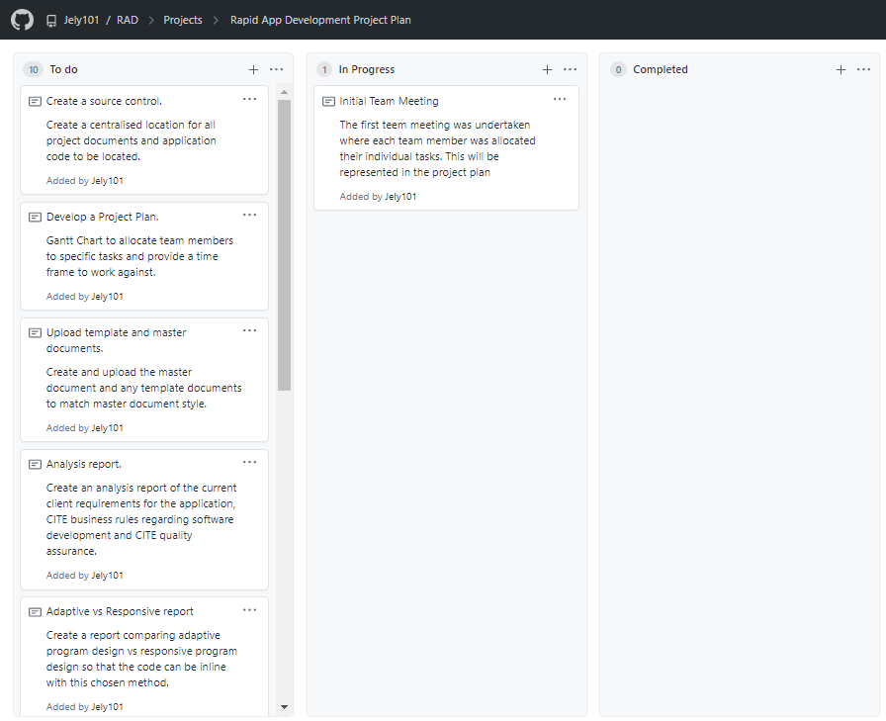

Figure 1 Project development cards. Taken at the end of the first meeting.

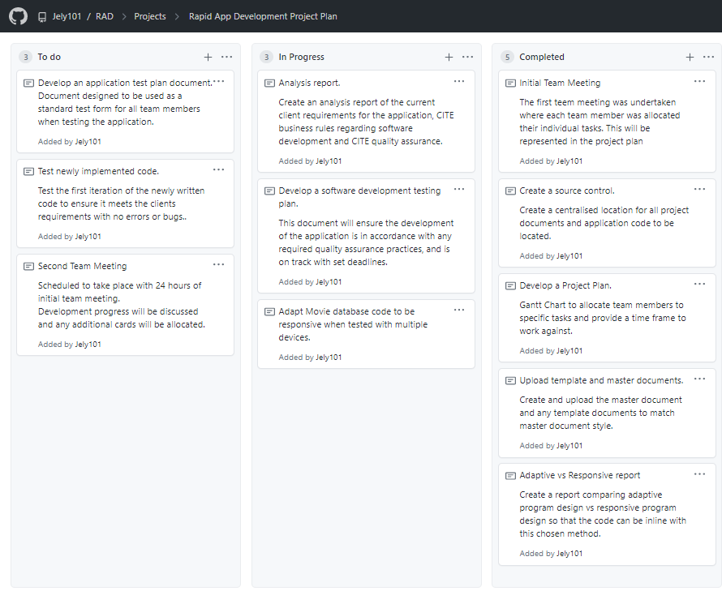

Figure 2 Project development cards. Taken at the end of the first day.

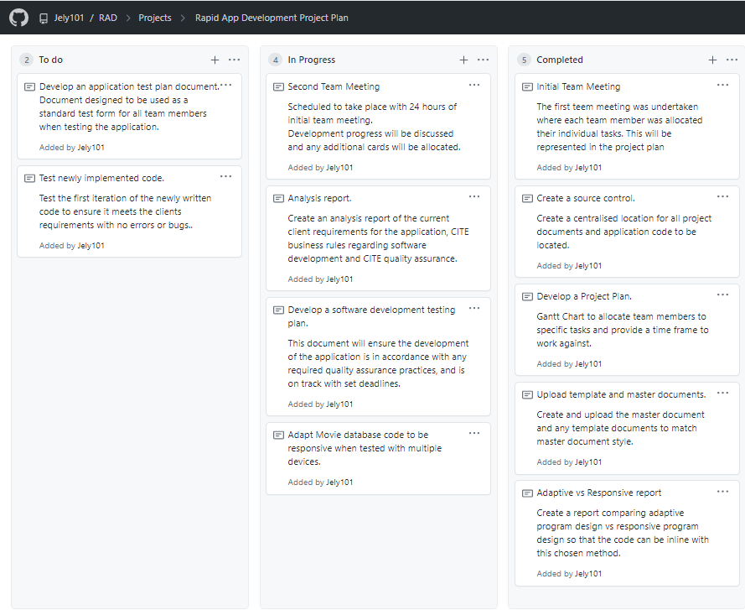

Figure 3 Project development cards. Taken at the end of the second team meeting.

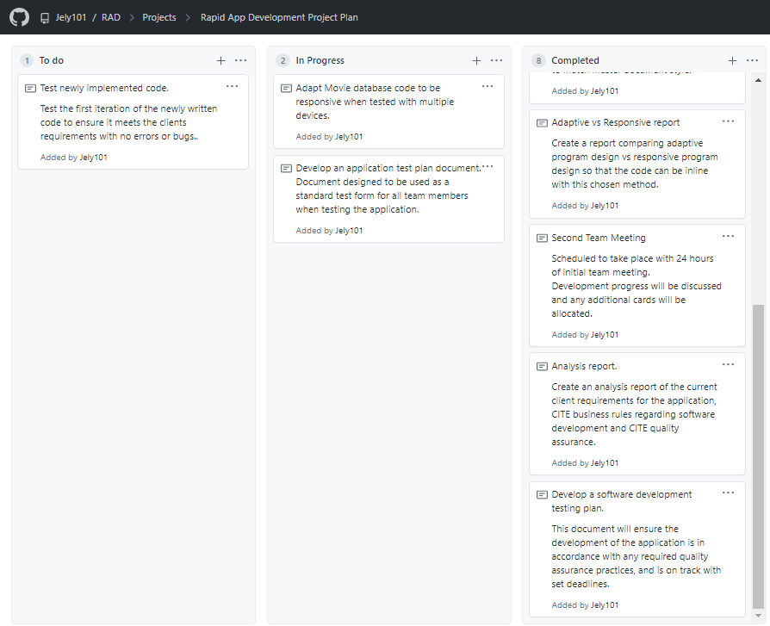

Figure 4 Project development cards. Taken at the end of the second day.

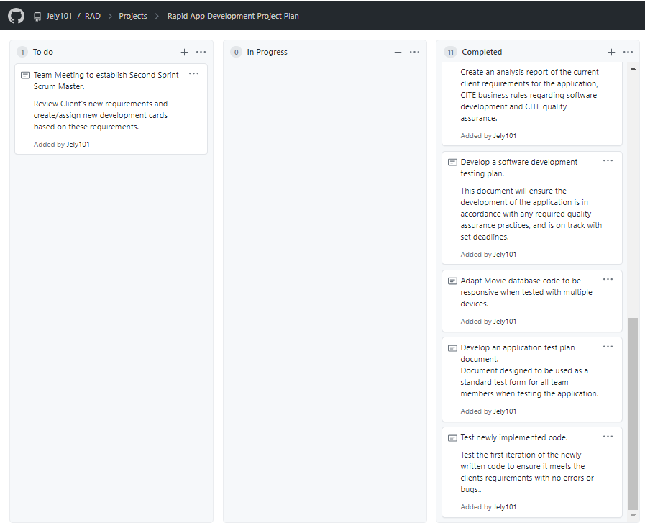

Figure 5 Project development cards. Taken at the end of the fifth day.

# Project Management Plan (Sprint one)

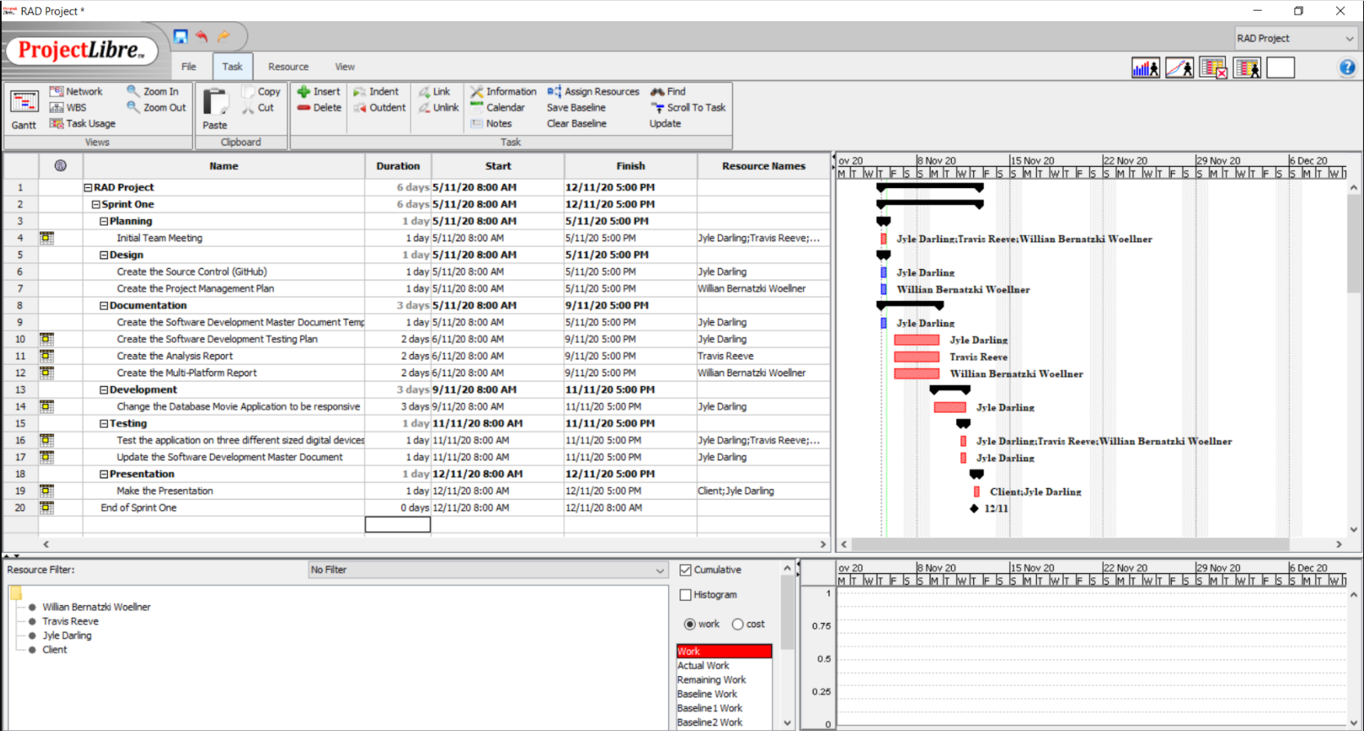

The current project plan can be accessed and downloaded at:

<https://github.com/Jely101/RAD/blob/main/Project%20Management%20Plan.pod>

# Software Development Testing Plan

## Purpose and Scope

This Software Quality Assurance Plan provides a foundation for managing the CITE Manages Services (CITE MS) software quality assurance activities and is based on project activities and work products as documented in the CITE MS Project Plan.

This plan:

• Identifies the SQA responsibilities of the project team.

• Defines CITE MS reviews and audits and how they will be conducted.

• Lists the activities, processes, and work products that the SQA team will review and audit.

• Identifies the SQA work products.

## SQA Team Roles and Responsibilities

|  |  |  |  |
| --- | --- | --- | --- |
| **Number** | **Member** | **Roles** | **Responsibility** |
| 1 | Jyle | SQA Leader | Develop and document quality standard and process for all management process  Manage software quality assurance activities for the project. |
| 2 | Travis | SQA Auditor | Perform SQA tasks, report to SQA leader the result of SQA review. |
| 3 | Willian | SQA Auditor | Perform SQA tasks, report to SQA leader the result of SQA review. |

## Work Products to be Reviewed

|  |  |  |  |  |
| --- | --- | --- | --- | --- |
| **Number** | **Development Phase** | **Product** | **Permission** | **Granted to Person** |
| 1 | Sprint One | Management plan | Read | Jyle |
| 2 | Sprint One | Analysis Report | Read | Jyle |
| 3 | Sprint One | Multi-platform report | Read | Travis |
| 4 | Sprint One | Software Development test report | Read | Willian |
| 5 | Sprint One | Application test reports | Read | SQA Team |

## SQA Task Schedule

|  |  |  |  |
| --- | --- | --- | --- |
| **Date** | **SQA Task** | **Person In charge** | **Description** |
| 6/11/20 | Evaluate Management plan | Jyle | Analysis report review, project plan review. |
| 6/11/20 | Review multi-platform report | Travis | Review Multi-platform report. |
| 9/11/20 | Review Software Development test report. | Willian | Review software development test report. |
| 11/11/20 | Review application test reports | SQA team | Review application test reports. |

## Reference Materials

Reference materials used to develop the CITE MS SQAP include:

* ISO/IEC/IEEE 12207:2017 Systems and software engineering — Software life cycle processes.
* CITE Managed Services Quality Management Policies and Procedures.

## Standards and Methodology

The following standards or methodologies were used to train team members in order to better prevent against any defects from occurring in the management and development process. These standards were taken from CITE Managed Services, in accordance with our ongoing contract.

* IEEE Guide to Software Requirements Specifications
* IEEE Guide to Software Design Descriptions
* IEEE Standard for Software User Documentation
* INITIATION AND PLANNING - Project specification analysis, test plan elaboration and team assignment.
* FIRST REVIEW - Initial testing of first development deliverables, refining the test plan and test items.
* ITERATION AUDITS - Ongoing testing of intermediate iterations builds.
* FINAL VERIFICATION AND VALIDATION - Final product testing to ensure bespoke quality and readiness for deployment.

## Audits or Reviews

Quality Assurance for this project will include at least one audit of all current draft deliverables and selected work products in each stage of development. The reviews will assure that the established system development and project management processes and procedures are being followed effectively, and exposures and risks to the current Project Plan are identified and addressed.

The following diagram depicts the In-Stage Assessment process flow for all CITE MS development stages:

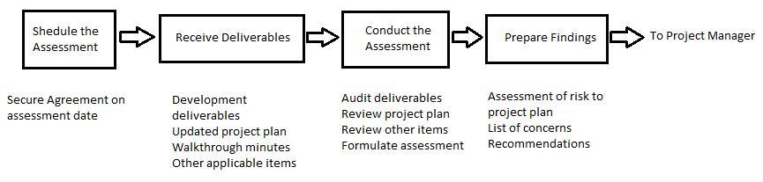

Each deliverable and/or selected work product will be audited to make judgements as to the quality and validity of the deliverable or work product. The assessment will include any verification or validation activities performed since the last In-Stage Assessment.

## SQAP Checklist

|  |  |  |  |
| --- | --- | --- | --- |
| **Software Quality Assurance Activity** | **Yes** | **No** | **N/A** |
| I. Project Plan |  |  |  |
| Team meeting to discuss project requirements | X |  |  |
| Project requirements allocated amongst team members | X |  |  |
| Project plan provides clear guidance on time frames expected of each task | X |  |  |
| Project plan was completed on time | X |  |  |
| Project plan meets expected QA guidelines | X |  |  |
|  | | | |
| II. Analysis Report |  |  |  |
| Application requirements are identified and defined | X |  |  |
| CITE MS Business rules are defined | X |  |  |
| CITE MS Quality Assurance practices are defined | X |  |  |
| Report is completed on time | X |  |  |
| Report meets expected QA guidelines | X |  |  |
|  | | | |
| III. Multi-platform Report |  |  |  |
| Report provides descriptions of each development method | X |  |  |
| Report provides pros and cons for each development method | X |  |  |
| Report provides a clear reason for the chose development method | X |  |  |
| Report was completed on time | X |  |  |
| Report meets expected QA guidelines | X |  |  |
|  | | | |
| IV. Software Development Test Report |  |  |  |
| Report identifies the SQA responsibilities of the project team. | X |  |  |
| Report Defines CITE MS reviews and audits and how they will be conducted. | X |  |  |
| Report Lists the activities, processes, and work products that the SQA team will review and audit. | X |  |  |
| Report Identifies the SQA work products. | X |  |  |
| Report was completed on time | X |  |  |
| Report meets expected QA guidelines | X |  |  |
|  | | | |
| V. Application Test Reports |  |  |  |
| Sufficient number of test cases were conducted to ensure product meets client requirements | X |  |  |
| Each team member assigned completed their report on time | X |  |  |
| Reports meet expected QA guidelines | X |  |  |

# Analysis Report

## CITE Business rules

CITE managed services has a set of business rule that define the development process for all projects. These business rules include.

* Client’s interests always come first.
* We are performance orientated and unafraid to make decisions and be accountable for those decisions.
* Without compromise we will operate in an ethical manner and in compliance with regulations.
* We aim to deliver the best products and service in the market.
* We will constantly strive to find a better solution to a client’s problem.
* Individual creativity is encouraged to create a great team working environment.
* Be capable of undertaking the largest projects our clients could conceive while remaining small enough to maintain the loyalty and comradery of all of our clients.
* We anticipate changes in the markets and technologies and will deliver the latest service, tools and technologies to our clients.
* While we strive to grow our business aggressively, we will always be fair competitors and will never denigrate other firms.
* We expect our people to maintain high ethical standards in everything they do.

## CITE Quality assurance

CITE managed services has a quality management system comprising a complex set of engineering and managerial activities that ensure bespoke quality of delivered software throughout the entire workflow. Their procedures and regulations are based on industry standards and best practices. Product lifecycle monitoring ensures compliance with processes and guidelines. Product quality verification and validation ensures all products comply with client business needs and expectations. CITE promotes effective collaboration between all project team members. To ensure all CITE software is of a high quality all project follow these steps in quality management.

Quality planning – A plan that govern the applicable set of standards, regulations, procedures, guidelines and tools during the development lifecycle in each project.

Quality assurance – Established processes that evaluate project performance and aim to assure that quality standards are being followed and that the deliverables comply with customer requirements.

Quality control – Measuring performance trends to identify defective pieces of code, verify that deliverables are of a high quality and that they are complete and correct.

CITE has an independent quality assurance department responsible for full-cycle quality testing, document and code reviews, defect tracking, configuration management process monitoring and risk management. A lead quality specialist is involved in initial business analysis and requirement specifications on all projects. The quality assurance team will provide reports on functional and regression testing, GUI and usability testing, accessibility testing, compatibility testing, performance testing, installation and configuration testing, system and integration testing, security testing, localization and internationalization testing and user acceptance testing.

## ACME Development requirements

The development requirements for this Movie Database application are.

* Use a RAD and agile software lifecycle methodology for development.
* Must be usable across all major digital platforms.
* A Multi-platform report on the merits of the two design options, adaptive and responsive.
* Rework the prototype to use the chosen design option.
* Movie database hosted on cloud or local server.
* A testing plan for the prototype.

# Multi-Platform Report

## Adaptive Design

Adaptive designs consist of multiple renditions of the same design – one for each size, as chosen by the designer or UI developer. Each version of the design is assigned to specific browser widths, called ‘anchor points’. Anchor points tell the browser exactly when to jump to the next layout. (Erickson, 2020)

Instead of using percentages, an adaptive design will utilize exactly one static layout per each anchor point, and adjust to the screen size once that anchor point has been detected. (Erickson, 2020)

Adaptive design can be complex because the designers have to create some different designs on the same page.

Pros and Cons of Adaptive Design. (Charlton, 2014)

|  |  |
| --- | --- |
| **Pros** | **Cons** |
| Super-efficient page loads: Adaptive websites are much better for load time performance and overall user experience. This is because adaptive delivery works by only transferring those assets necessary for the specific device and optimizing images and multimedia content on the fly to suit display resolution and size. | Resource and budget heavy: Adaptive requires a large team of developers and the budget to handle the complexity that comes with choosing to develop and support an adaptive site. |
| No need to scratch your existing website completely: Developers don’t have to go back to the drawing board and re-code the existing website from scratch. | Complexity: Adaptive is a good approach, but creating too many separate designs takes a lot of work and can defeat the purpose of trying to use one set of content on one URL. |

## Responsive Design

In Responsive Design, a website will change its appearance based on the viewport of the browser. Typically developers use the width of the browser as the variable which determines the size of the dynamically changing elements on the page. (Erickson, 2020)

A responsive website is entirely fluid and will adjust and respond to the viewport no matter the size of the browser window (or screen). That is because it uses percentage-based CSS rules to change the style based on the device size. (Erickson, 2020)

Pros and Cons of Adaptive Design. (Jia, 2017)

|  |  |
| --- | --- |
| **Pros** | **Cons** |
| Save cost on responsive web design development: Comparing with the development of websites on PC, iPad, and mobile phones, responsive design is more conducive to saving design and development costs. | Slow down the loading: It will take longer to load for some responsive websites. It’s not a big deal because some unnecessary HTML/CSS will be loaded. |
| User experience friendly: The responsive design can provide users with a friendly web interface, as it can adapt to almost all devices on the screen, including smartphones, tablets, TV, PC monitors, iPhone, and Android phones which contribute to the mobile-friendly website design. | Bad compatibility for the old version of the IE browser: If the site users are mostly using the old version of IE, it is not recommended to do responsive design. |

## The Choice

Analysing the whole scenario of the application, where it needs to be across all major digital devices, the choice of the developer team is the Responsive Design. The main points for this choice are:

* The current website is easier to change to Responsive Design
* There are many templates available to use in a future change. For example Bootstrap
* There is no need for many developers to make the change.
* The development time is less than use Adaptive Design.
* The cost of the project is less because the time is less and there are fewer resources involved in the project.

# Demonstration Images

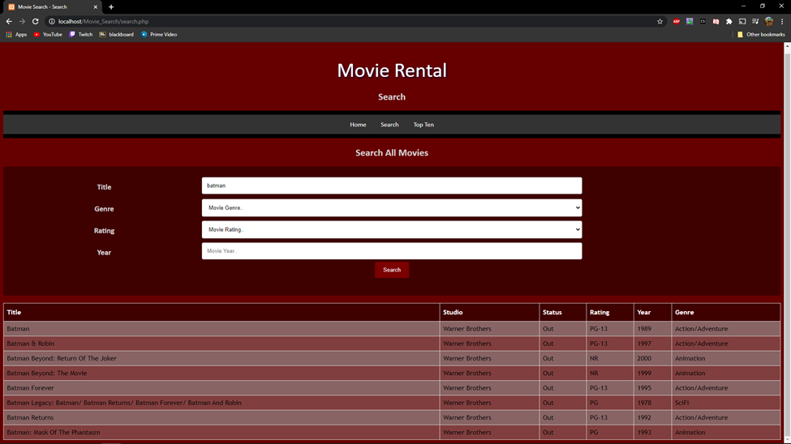

Figure 6 Desktop view of Search function and table populated with results.

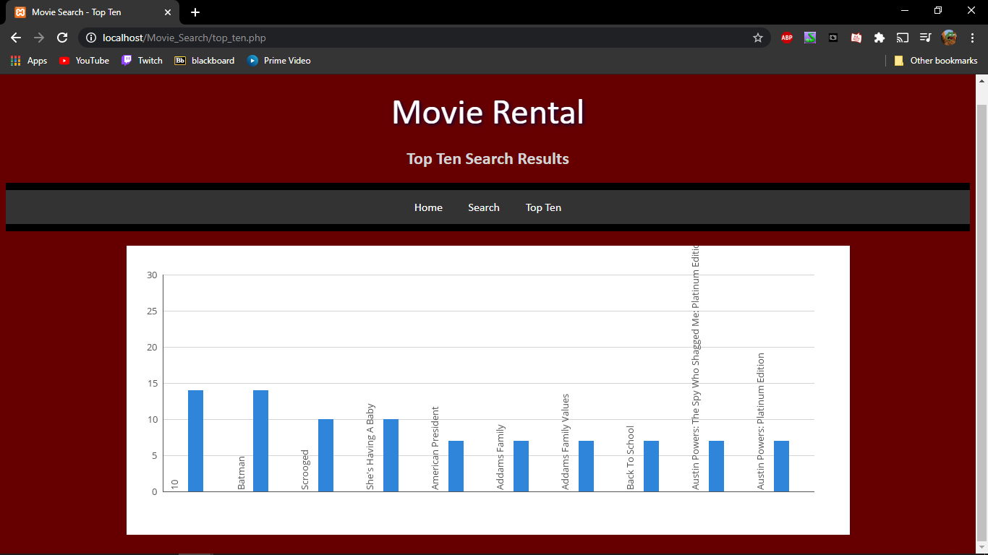

Figure 7 Desktop view of top ten chart populated with results.

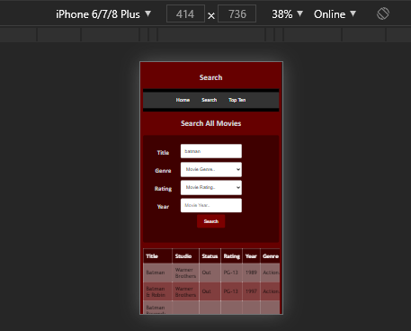

Figure 8 iPhone 6/7/8 Plus device view showing search function with search table results

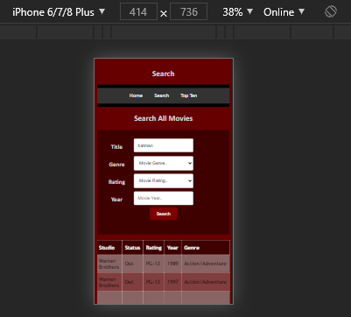

Figure 9 iPhone 6/7/8 Plus device view showing search function with search table results scrolled to show end of table.

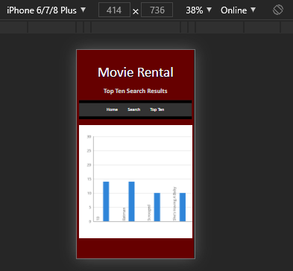

Figure 10 iPhone 6/7/8 Plus device view showing top ten search results image.

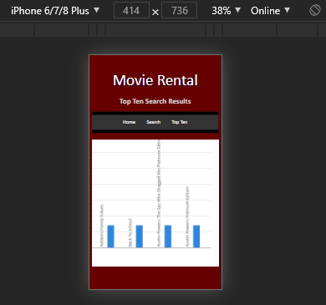

Figure 11 iPhone 6/7/8 Plus device view showing top ten search results scrolled to show rest of image.

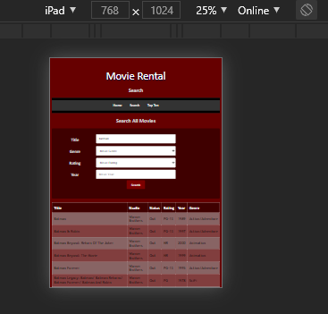

Figure 12 iPad device view showing search function with search table results.

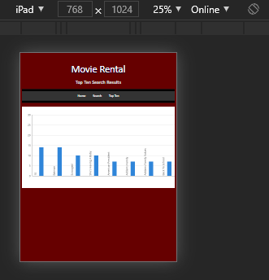

Figure 13 iPad device view showing top ten search results image.

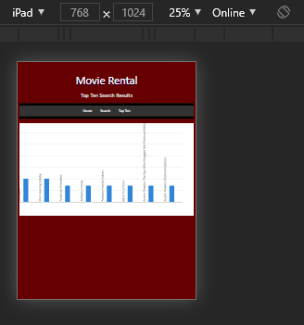

Figure 14 iPad device view showing top ten search results scrolled to show rest of image.

# Application Testing Documentation

Tester Jyle Darling

|  |  |  |  |  |
| --- | --- | --- | --- | --- |
| **Test Case** | **Description** | **Expected Result** | **Actual Result** | **Comments** |
| 01. Testing webpages load on different devices | Chrome used to load the various webpages on different devices using the device toolbar within the F12 menu. | Webpages load and display as normal, images or charts scroll correctly when devices with screen sizes smaller than image or chart size. | As expected | Ref to demonstration images. |
| 02. Searching for movie by Title. | Searching the database for a movie only using the movie title. Search term is in the database. | Table to be shown with search results. | As expected | Ref to demonstration images. |
| 03. Searching for movie by Genre. | Searching the database for a movie only using the movie Genre. | Table to be shown with search results. | As expected | Ref to demonstration images. |
| 04. Searching for movie by Rating. | Searching the database for a movie only using the movie Rating. | Table to be shown with search results. | As expected | Ref to demonstration images. |
| 05. Searching for movie by Year. | Searching the database for a movie only using the movie Year. | Table to be shown with search results. | As expected | Ref to demonstration images. |
| 06. Searching for movie by combination of title, Year. | Searching the database for a movie using the movie Title and Year. | Table to be shown with search results. | As expected | Ref to demonstration images. |
| 07. Searching for movie by combination of Genre, Rating | Searching the database for a movie using the movie Genre and Rating. | Table to be shown with search results. | As expected | Ref to demonstration images. |
| 08. Top ten has updated. | Checking to see if the top ten list has updated with the extra searches. | New top ten chart to be shown with different values based on the new search terms. | AS expected | Ref to demonstration images. |

Tester Willian Bernatzki Woellner.

|  |  |  |  |  |
| --- | --- | --- | --- | --- |
| **Test Case** | **Description** | **Expected Result** | **Actual Result** | **Comments** |
| 01. Testing webpages load on different devices | Chrome used to load the various webpages on different devices using the device toolbar within the F12 menu. | Webpages load and display as normal, images or charts scroll correctly when devices with a screen size smaller than image or chart size. | All pages are loaded in different sizes, but there is a label (comment) on the Home page. | Ref. Figure 1  Ref. Figure 2  Ref. Figure 3 |
| 02. Searching for a movie by Title. | Searching the database for a movie only using the movie title. The search term is in the database. | Table to be shown with search results. | As expected | Ref.Figure 4  Ref Figure 5 |
| 03. Searching for a movie by Genre. | Searching the database for a movie only using the movie Genre. | Table to be shown with search results. | As expected | Ref. Figure 6  Ref. Figure 7 |
| 04. Searching for a movie by Rating. | Searching the database for a movie only using the movie Rating. | Table to be shown with search results. | As expected | Ref. Figure 8  Ref. Figure 9 |
| 05. Searching for a movie by Year. | Searching the database for a movie only using the movie Year. | Table to be shown with search results. | As expected | Ref. Figure 10  Ref. Figure 11 |
| 06. Searching for a movie by a combination of title, Year. | Searching the database for a movie using the movie Title and Year. | Table to be shown with search results. | As expected | Ref. Figure 12  Ref. Figure 13 |
| 07. Searching for a movie by a combination of Genre, Rating | Searching the database for a movie using the movie Genre and Rating. | Table to be shown with search results. | As expected | Ref. Figure 14  Ref. Figure 15 |
| 08. Top ten has been updated. | Checking to see if the top ten list has been updated with the extra searches. | The new top ten chart to be shown with different values based on the new search terms. | As expected | Ref. Figure 16  Ref. Figure 17 |

Tester Travis Reeve.

|  |  |  |  |  |
| --- | --- | --- | --- | --- |
| **Test Case** | **Description** | **Expected Result** | **Actual Result** | **Comments** |
| 01. Testing webpages load on different devices | Chrome used to load the various webpages on different devices using the device toolbar within the F12 menu. | Webpages load and display as normal, images or charts scroll correctly when devices with a screen size smaller than image or chart size. | Correct | Ref. Figure 1  Ref. Figure 2 |
| 02. Searching for a movie by Title. | Searching the database for a movie only using the movie title. The search term is in the database. | Table to be shown with search results. | Correct | Ref.Figure 3 |
| 03. Searching for a movie by Genre. | Searching the database for a movie only using the movie Genre. | Table to be shown with search results. | Correct | Ref. Figure 4 |
| 04. Searching for a movie by Rating. | Searching the database for a movie only using the movie Rating. | Table to be shown with search results. | Correct | Ref. Figure 5 |
| 05. Searching for a movie by Year. | Searching the database for a movie only using the movie Year. | Table to be shown with search results. | Correct | Ref. Figure 6 |
| 06. Searching for a movie by a combination of title, Year. | Searching the database for a movie using the movie Title and Year. | Table to be shown with search results. | Correct | Ref. Figure 7 |
| 07. Searching for a movie by a combination of Genre, Rating | Searching the database for a movie using the movie Genre and Rating. | Table to be shown with search results. | Correct | Ref. Figure 8 |
| 08. Top ten has been updated. | Checking to see if the top ten list has been updated with the extra searches. | The new top ten chart to be shown with different values based on the new search terms. | Correct | Ref. Figure 9 |

Sprint Two

Scrum Master Willian Bernatzki Woellner

# Source Control Snapshot

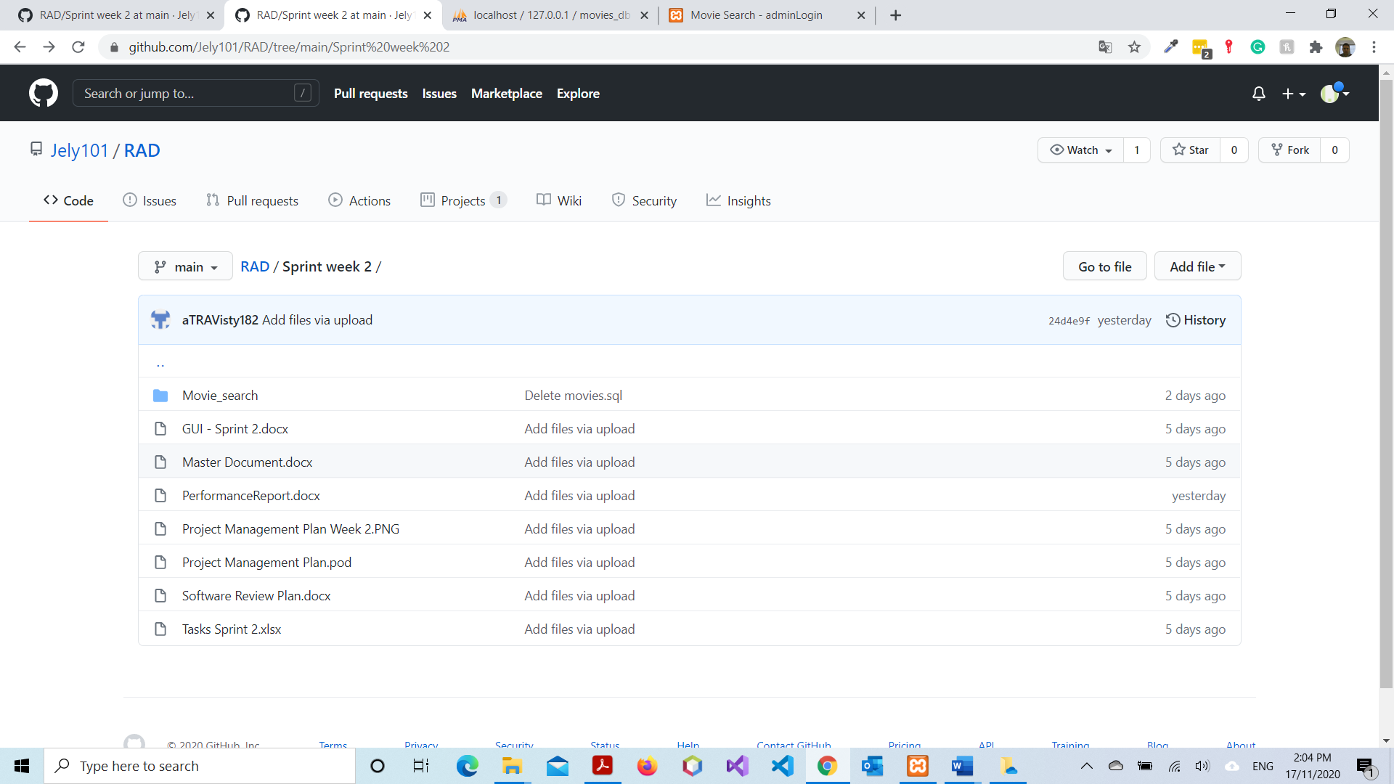

Current Source Control can be viewed at <https://github.com/Jely101/RAD>

# Software Review Plan

## Meeting Minutes

This is a record of the meeting minutes from our meeting with CITE MS.

Meeting Name and place: Sprint Two requirements QA and design, conducted at SMT room T01

Date and time: 12/11/20 10:00 am

List of Participants: Jyle Darling, Willian Bernatzki Woellner, and CITE Representative Stewart Godwin

Purpose of the meeting: To verify application design against CITE quality assurance practices.

Agenda items:

* General app requirements. A list of requirements was provided for the next sprint. These requirements were sent in a document.
* Additional requirements. Further requirements were determined in the conversation, these requirements were written down and emailed to the development team leader.
* CITE QA guidelines relevant to this project. Discussed the proposed UI and the standards that surround implementing it to meet those standards.
* Next Meeting: this has been determined to take place after sprint two presentation on the 19th of November at 10 am.

## Application Requirements

Sprint two client application requirements that were discussed during the meeting:

• The website includes a free communications membership sign-up method for users.

• The membership sign up method is will require users to select a monthly email, or breaking news notifications.

• The membership sign up will require a full name and email to sign up.

• The membership sign up will provide a method for users to unsubscribe from communications.\

• The removal process will send an email to an administrator who will remove the user from the mailing list.

• A new database table will be needed to house the member's full name, email, mailing list preferences, and if they are to remain on the mailing list.

• All user membership details are to be fully validated to filter out incorrect or erroneous information.

• An admin UI is to be implemented.

• Admins are required to log in before gaining access to the list of members.

• Admins must have to ability to remove user information from the membership table.

• Admins should have their database table that stores admin email and password.

• All admin details are to be fully validated to filter out incorrect or erroneous information.

## CITE Coding standards and QA testing.

The following information was discussed in the meeting with CITE to ensure that the continued design and implementation of the application and its code remains in scope with the CITE guidelines.

Coding standards to follow:

• Naming Conventions

• File Naming and Organization

• Formatting and Indentation

• Comments and Documentation

• Classes, Functions and Interfaces

• Pointer and Reference Usage

• Testing

Further information on these standards are covered in:

ISO/IEC/IEEE 12207:2017 Systems and software engineering — Software life cycle processes

Quality Assurance relevant tests:

• Functional and Regression Testing;

• GUI and Usability Testing;

• Accessibility Testing;

• Compatibility Testing;

• Performance Testing;

• Installation / Configuration Testing;

• System / Integration Testing;

• Security Testing;

Further information on these test procedures can be found at:

CITE Managed Services Policies and Procedures.

## GUI – Graphical User Interface

Subscribe

* The Subscribe form will be available on the Home Page.
* Full Name, Email, and one option for the newsletter must be required to subscribe.
* The system will check if the email already exists on the database and if it is in the correct format.
* To access the Unsubscribe option, the user must click on the Unsubscribe link below the Subscribe button.
* To access the Admin area, the user must click on the Admin Login button.

Unsubscribe

* To unsubscribe the user must click on the Unsubscribe button, the Email is required.
* The email will be validated if it exists on the database and after the system will send the message to the administrator to remove the

Login

* To access the Admin Login option, the administrator must click on the Admin Login button on the Home Page.
* The email and password are required to login to the administrator area.

Membership Administrator

* The admin will be 2 options to remove a membership.
* The first Option: The admin must enter the email and click on the remove button. The administrator will receive a message by email to remove each membership.
* The last option: The admin can click on the remove button inside the table where all members will be displayed.

## Database Designer

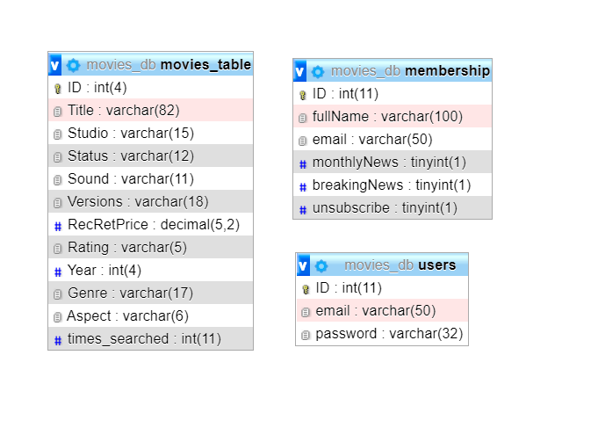

# Performance Report

To measure the performance of the website we will be using website monitoring tools. With these tools, we can continuously monitor downtime patterns and locate the culprits. They provide detailed information on your website’s performance including visitor counts, uptime, bounce rates, page loading times, and other crucial information to guarantee the development of a successful website. Alongside these performance metrics, these tools notify you about issues like device failure, bandwidth overload, and problems with the web hosting provider. The website monitor tools work by monitoring the website's communication layer including the HTTP and TCP, internal and external DNS’s, internet service providers, and content delivery networks.

## Performance Tools

Five common monitoring tools that could be used to monitor the performance of the website include.

### • Google PageSpeed Insight (PSI)

The PageSpeed insight tool provides real-time performance data for a website. The data is collected irrespective of the device the website is viewed on. It incorporates data from the Chrome User Experience Report (CrUX) to provide user experience metrics. The tool is easy to use and will categorize a website as fast slow or average based on its speed score. It will also provide an optimization score evaluating how well a webpage follows performance best practices.

### • GTmetrix

GTmetrix is a very popular tool for analyzing site speed performance. The tool uses PageSpeed Insight and Yslow to generate performance scores and a detailed report on the current state of a website. GTmetrix is easy to use and allows customization of the test configuration.

### • WebPageTest (WPT)

WebPageTest is a free, open-source website performance testing tool. It captures useful metrics from the website and displays them in tables and charts allowing the user to spot performance delays and loopholes. The tool will work on any browser and any device from any location. This tool has advanced features for running multiple tests, changing the connection speed, and allows you to capture video of the test. Data collected from these tests include load times, time to the first byte, speed index, DOM elements, and start render time, document complete time, and fully loaded time.

### • Dotcom-Monitor

Dotcom-Monitor gives the user insight into application performance and the state of the website. It lets you monitor servers, web applications, network availability and performance, and website page load speeds. It allows you to choose the browser you use and also the location to test from.

### • SolarWinds Pingdom

SolarWinds is a free website monitor tool designed to help analyse every element of the website. This tool will both point out issues on the website and offer solutions on how to fix the problem. It will also provide information on the number of requests per domain, type of content, size analysis, and size per domain.

## Recommendation

Each of these tools provides key performance data on a website while also providing unique features designed to help monitor and improve a website. If I were developing a shopfront website for a business, where the performance for the site could mean the difference between a sale and a potential long-term client or the client going somewhere else I would be using the SolarWinds Pingdom tool. The plethora of data provided by this program coupled with both a free and a paid option that will provide the necessary data no matter the size of the client makes this the right tool no matter what the needs of the clients may be. Also, this is the only tool that both identifies issues but also provides solutions to those issues. Having said that for this basic movie search program I will do the performance testing using GTmetrix. As I only need basic performance data its ease of use trumps the detailed report provided by SolarWinds.

(Top 5 Website Monitoring Tools to Measure and Improve your Page Speed, n.d.)

# Project Management Plan (Sprint Two)

The current project plan can be accessed and downloaded at:

<https://github.com/Jely101/RAD/blob/main/Sprint%20week%202/Project%20Management%20Plan%20Week%202.PNG>

# Software Development Testing Plan (Sprint Two)

## Purpose and Scope

This Software Quality Assurance Plan provides a foundation for managing the CITE Manages Services (CITE MS) software quality assurance activities and is based on project activities and work products as documented in the CITE MS Project Plan.

This plan:

• Identifies the SQA responsibilities of the project team.

• Defines CITE MS reviews and audits and how they will be conducted.

• Lists the activities, processes, and work products that the SQA team will review and audit.

• Identifies SQA work products.

## SQA Team Roles and Responsibilities

|  |  |  |  |
| --- | --- | --- | --- |
| **Number** | **Member** | **Roles** | **Responsibility** |
| 1 | Jyle | SQA Leader | Develop and document quality standard and process for all management process  Manage software quality assurance activities for the project. |
| 2 | Travis | SQA Auditor | Perform SQA tasks, report to SQA leader the result of SQA review. |
| 3 | Willian | SQA Auditor | Perform SQA tasks, report to SQA leader the result of SQA review. |

## Work Products to be Reviewed

|  |  |  |  |  |
| --- | --- | --- | --- | --- |
| **Number** | **Development Phase** | **Product** | **Permission** | **Granted to Person** |
| 1 | Sprint Two | Management plan | Read | Willian |
| 2 | Sprint Two | Performance Report | Read | Jyle |
| 3 | Sprint Two | Software Development test report | Read | Travis |
| 4 | Sprint Two | Application test reports | Read | SQA Team |

## SQA Task Schedule

|  |  |  |  |
| --- | --- | --- | --- |
| **Date** | **SQA Task** | **Person In-charge** | **Description** |
| 13/11/20 | Evaluate Management plan | Willian | Software review Plan, project plan review. |
| 16/11/20 | Review Performance Report | Jyle | Review Performance report. |
| 17/11/20 | Review Software Development test report. | Travis | Review software development test report. |
| 18/11/20 | Review application test reports | SQA team | Review application test reports. |

## Reference Materials

Reference materials used to develop the CITE MS SQAP include:

* ISO/IEC/IEEE 12207:2017 Systems and software engineering — Software life cycle processes.
* CITE Managed Services Quality Management Policies and Procedures.

## Standards and Methodology

The following standards or methodologies were used to train team members to better prevent any defects from occurring in the management and development process. These standards were taken from CITE Managed Services, in accordance with our ongoing contract.

* IEEE Guide to Software Requirements Specifications
* IEEE Guide to Software Design Descriptions
* IEEE Standard for Software User Documentation
* INITIATION AND PLANNING - Project specification analysis, test plan elaboration, and team assignment.
* FIRST REVIEW - Initial testing of first development deliverables, refining the test plan, and test items.
* ITERATION AUDITS - Ongoing testing of intermediate iterations builds.
* FINAL VERIFICATION AND VALIDATION - Final product testing to ensure bespoke quality and readiness for deployment.

## Audits or Reviews

Quality Assurance for this project will include at least one audit of all current draft deliverables and selected work products in each stage of development. The reviews will assure that the established system development and project management processes and procedures are being followed effectively, and exposures and risks to the current Project Plan are identified and addressed.

The following diagram depicts the In-Stage Assessment process flow for all CITE MS development stages:



Each deliverable and/or selected work product will be audited to make judgements as to the quality and validity of the deliverable or work product. The assessment will include any verification or validation activities performed since the last In-Stage Assessment.

## SQAP Checklist

|  |  |  |  |
| --- | --- | --- | --- |
| **Software Quality Assurance Activity** | **Yes** | **No** | **N/A** |
| I. Project Plan |  |  |  |
| Team meeting to discuss project requirements | X |  |  |
| Project requirements allocated amongst team members | X |  |  |
| The project plan provides clear guidance on time frames expected for each task | X |  |  |
| The project plan was completed on time | X |  |  |
| Project plan meets expected QA guidelines | X |  |  |
|  | | | |
| II. Performance Report |  |  |  |
| The report provides descriptions of the most common monitoring tools that could be used to monitor the performance of the website | X |  |  |
| The report provides the most appropriate code optimizers and performance tools that could be beneficial for the project a clear reason for the chose development method | X |  |  |
| The report was completed on time | X |  |  |
| The report meets expected QA guidelines | X |  |  |
|  | | | |
| III. Software Development Test Report |  |  |  |
| The report identifies the SQA responsibilities of the project team. | X |  |  |
| Report Defines CITE MS reviews and audits and how they will be conducted. | X |  |  |
| Report Lists the activities, processes, and work products that the SQA team will review and audit. | X |  |  |
| Report Identifies the SQA work products. | X |  |  |
| The report was completed on time | X |  |  |
| The report meets expected QA guidelines | X |  |  |
|  | | | |
| IV. Application Test Reports |  |  |  |
| A sufficient number of test cases were conducted to ensure the product meets client requirements | X |  |  |
| Each team member assigned completed their report on time | X |  |  |
| Reports meet expected QA guidelines | X |  |  |

# Application Testing Documentation

Tester: Willian Bernatzki Woellner

## Test Table

|  |  |  |  |  |
| --- | --- | --- | --- | --- |
| **Test Case** | **Description** | **Expected Result** | **Actual Result** | **Comments** |
| 01. Testing the webpages load on different devices. | Chrome used to load the various webpages on different devices using the device toolbar within the F12 menu. | Webpages load and display as normal, images or charts scroll correctly when devices with a screen size smaller than image or chart size. | As expected | Ref. Figure 1  Ref. Figure 2  Ref. Figure 3  Ref. Figure 4 |
| 02. Subscribe to new membership. | Subscribe to new membership. | The Full Name and Email fields should be required to subscribe to new membership. If a membership will create the system should display the message: Subscribe Successfully saved. | As expected | Ref. Figure 5  Ref. Figure 6 |
| 03. Request the Unsubscribe a membership. | Request the unsubscribe a membership that already exists on the database. | The email field should be required and the administrator should receive a message to unsubscribe the membership. The system should display the message: Unsubscribe Successfully saved. | As expected | Ref. Figure 7  Ref. Figure 8  Ref. Figure 9 |
| 04. Subscribe to new membership using an email already subscribed. | Subscribe to an existing membership. | Subscribe should be rejected. Email is already subscribed. | As expected | Ref. Figure 10 |
| 05. Request to Unsubscribe the membership that has already request unsubscribe. | Request to unsubscribe the membership that has already request to unsubscribe. | Unsubscribe should be rejected. Unsubscribe already requested or email not found. | As expected | Ref. Figure 11 |

|  |  |  |  |  |
| --- | --- | --- | --- | --- |
| 06. Logon on the Administrator Area. | Logon to the administrator area. | The Email and Password field should be required to log in. Unsubscribe Membership, All membership, and logout options should display after the login. | As expected | Ref. Figure 12  Ref. Figure 13  Ref. Figure 14 |
| 07. Remove a membership using the email. | Remove the membership to the database. | The email field should be required and validated to remove the membership. If the email is not found to unsubscribe the system should display the message: Membership cannot be removed. Unsolicited unsubscribe or email not found. | As expected | Ref. Figure 15  Ref. Figure 16  Ref. Figure 17 |
| 08. Remove a membership using the button on the table. | Remove the membership to the database using the remove button on the table. | The memberships displayed in this table should be only memberships that are requested to unsubscribe. After clicking on the remove button the membership should be removed from the database and the system should display the message Membership successfully removed. | As expected | Ref. Figure 17 |
| 09. Display all memberships | Display all memberships in a table with all information. | All memberships should be displayed in a table. | As expected | Ref. Figure 18 |
| 10. Try to access an administrator page without logon | Try to access an administrator page without logon. | The system should redirect to the login page. | As expected | Ref. Figure 19 |

### Figure 1

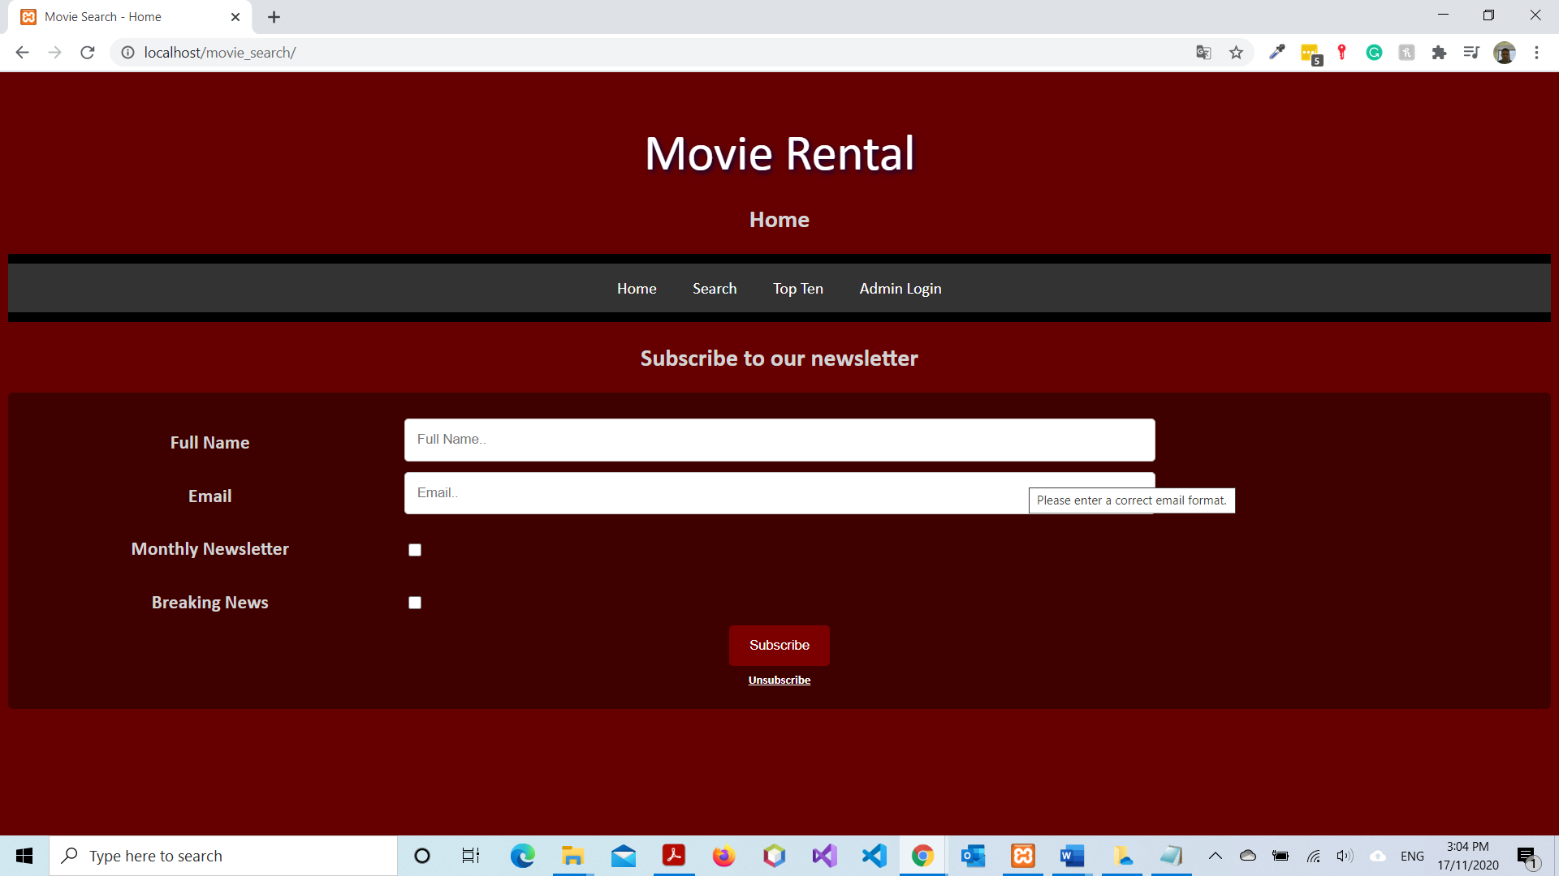

### Figure 2

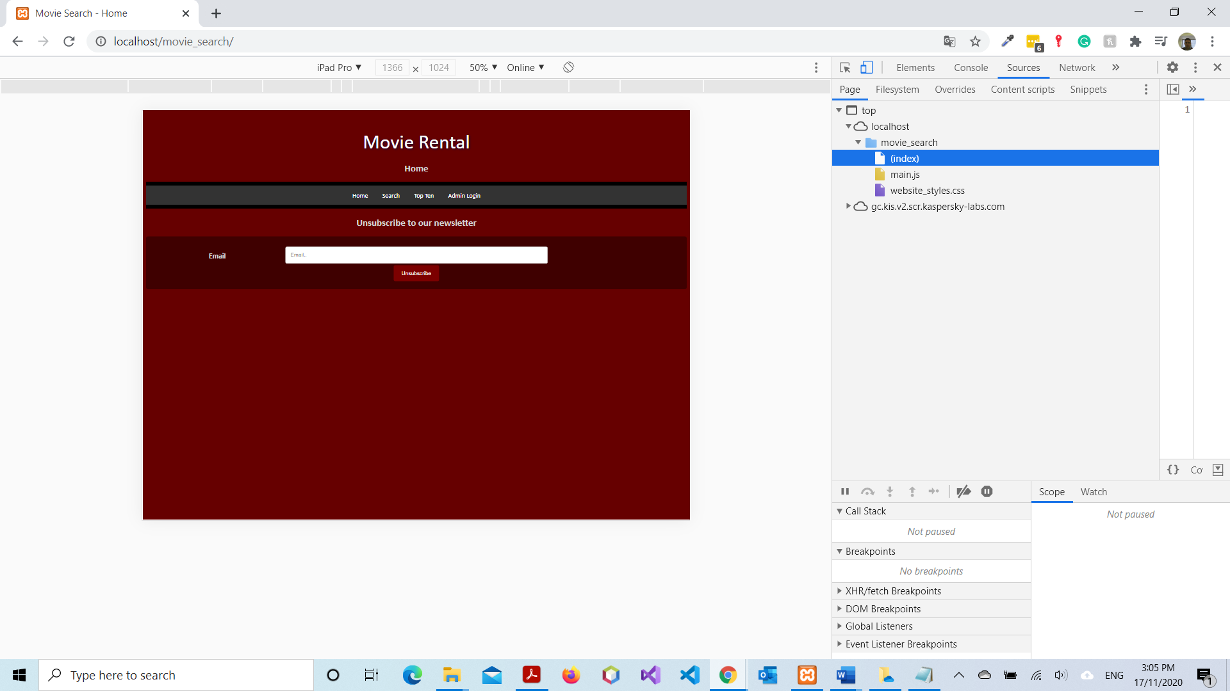

### Figure 3

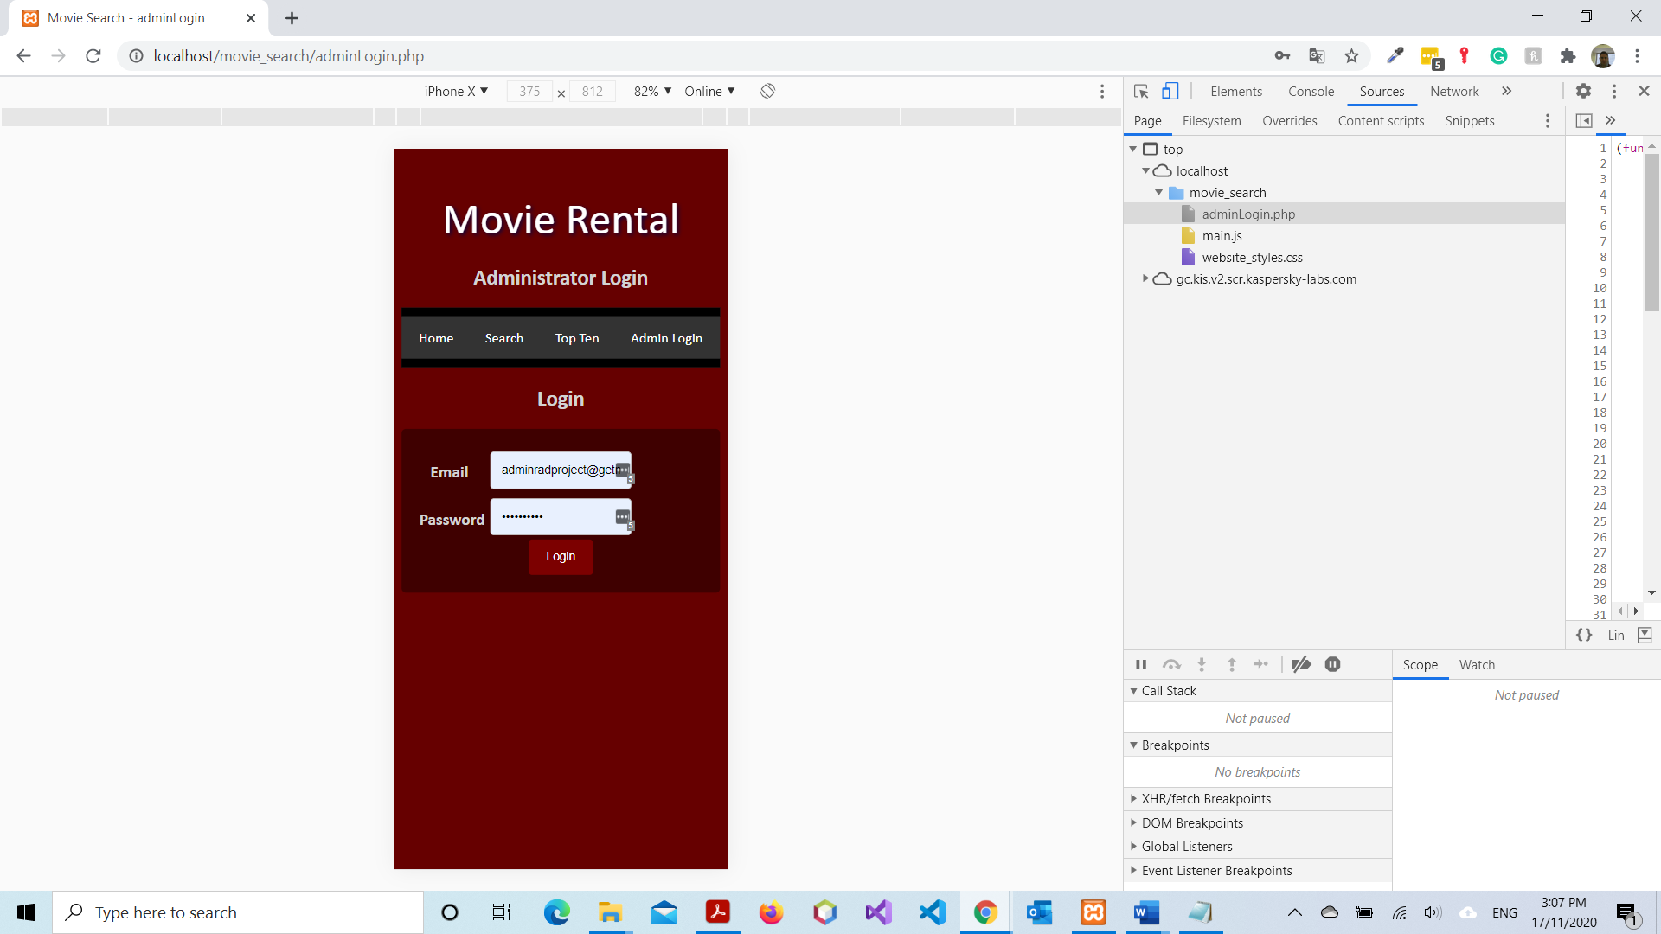

### Figure 4

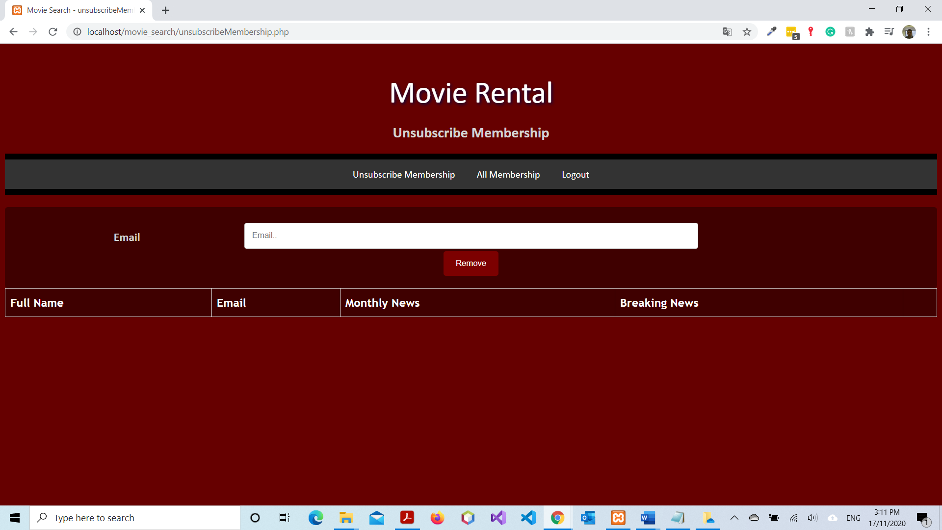

### Figure 5

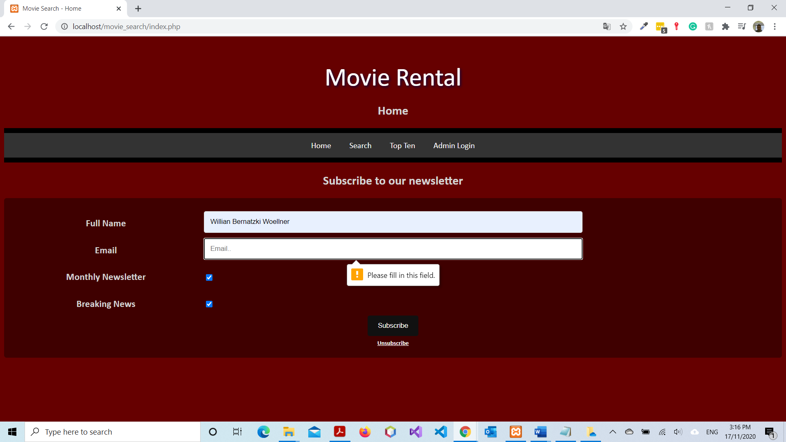

### Figure 6

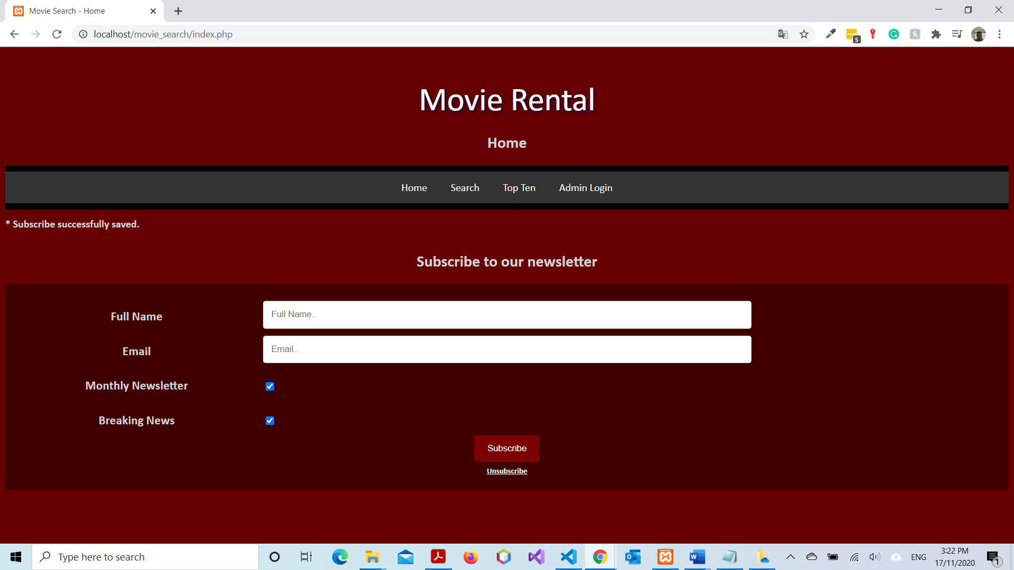

### Figure 7

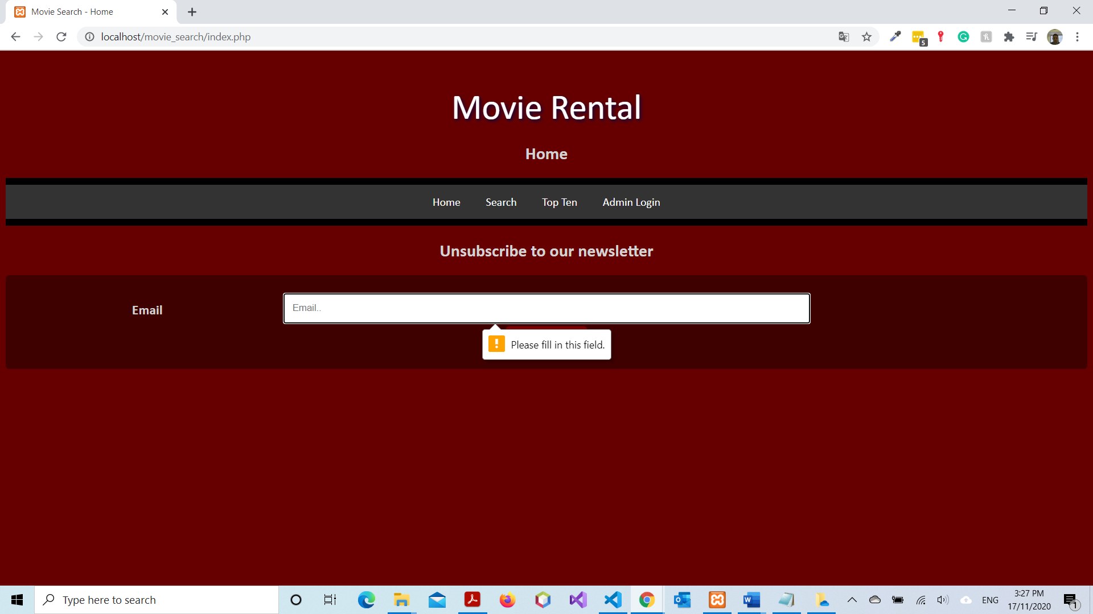

### Figure 8

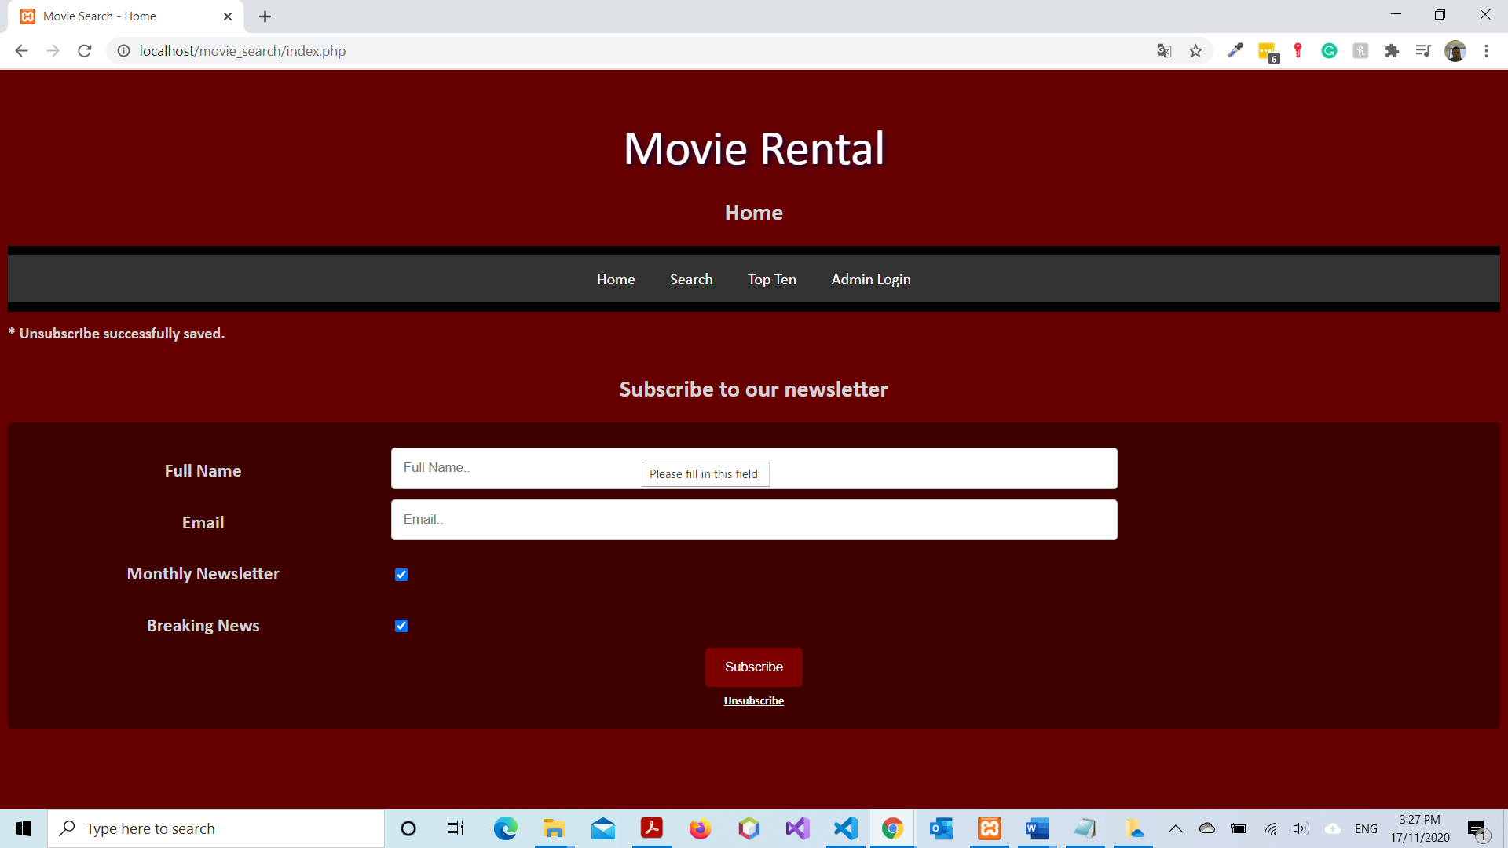

### Figure 9

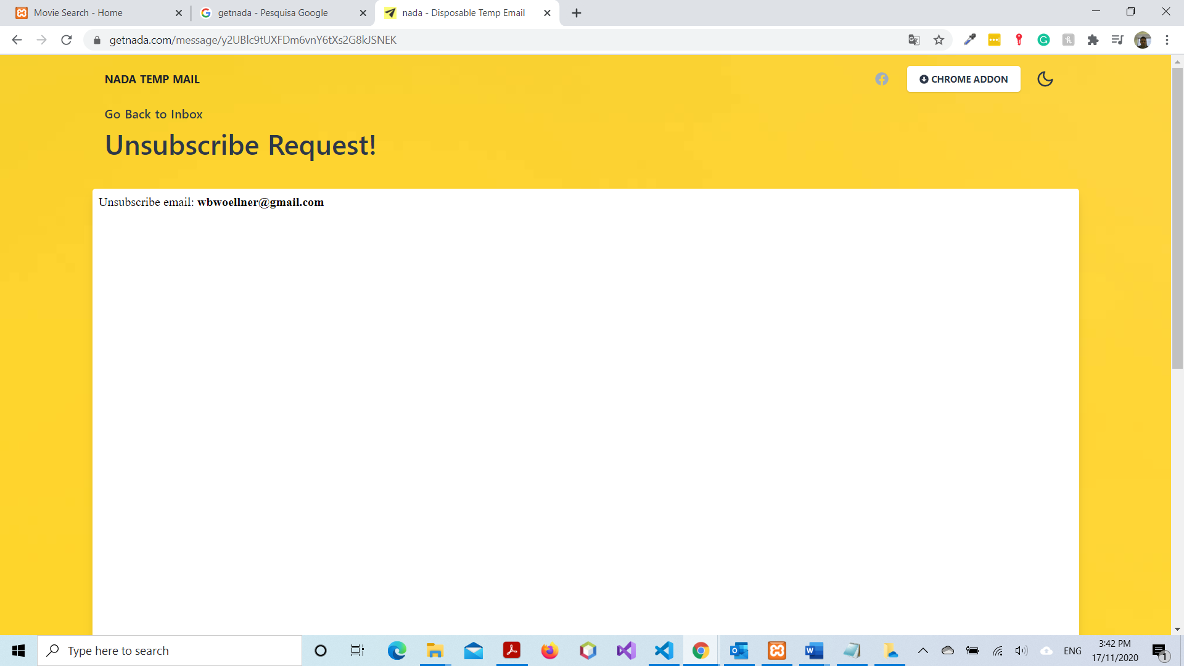

### Figure 10

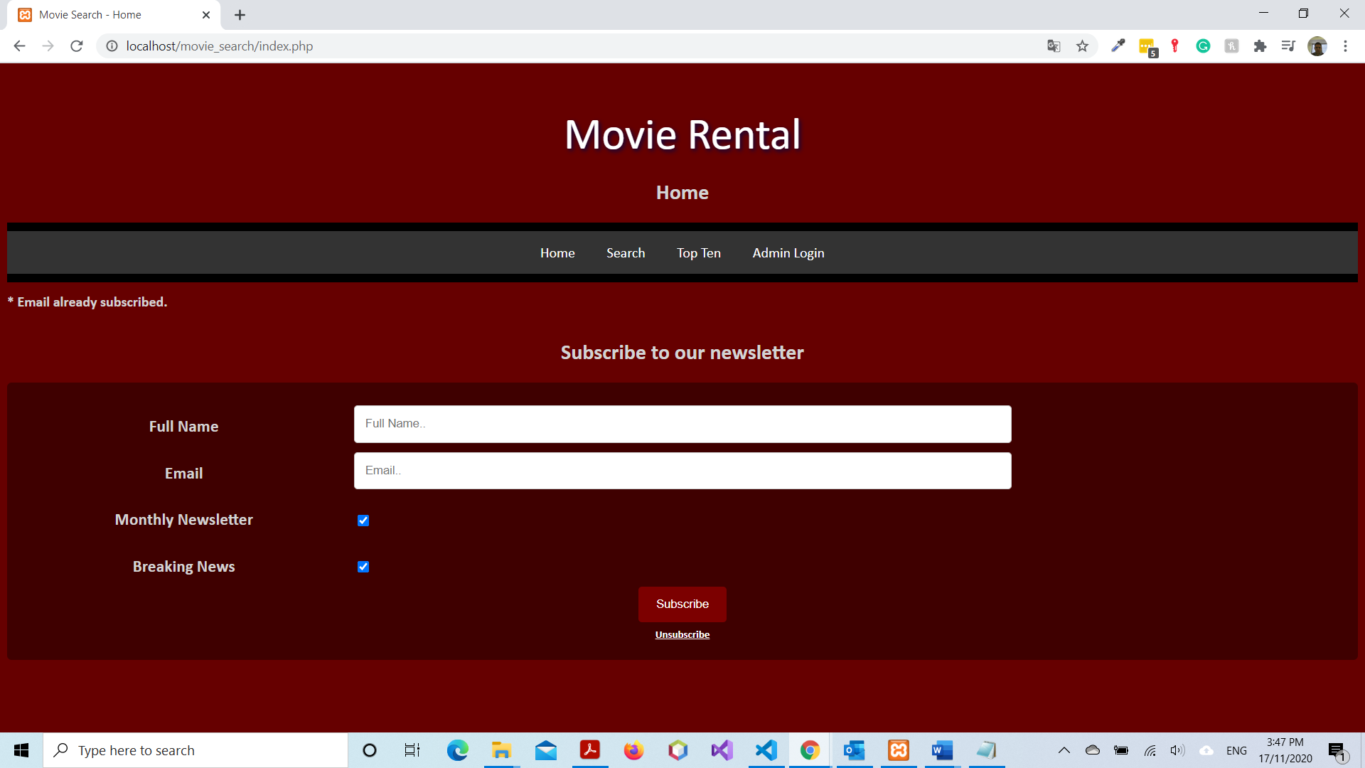

### Figure 11

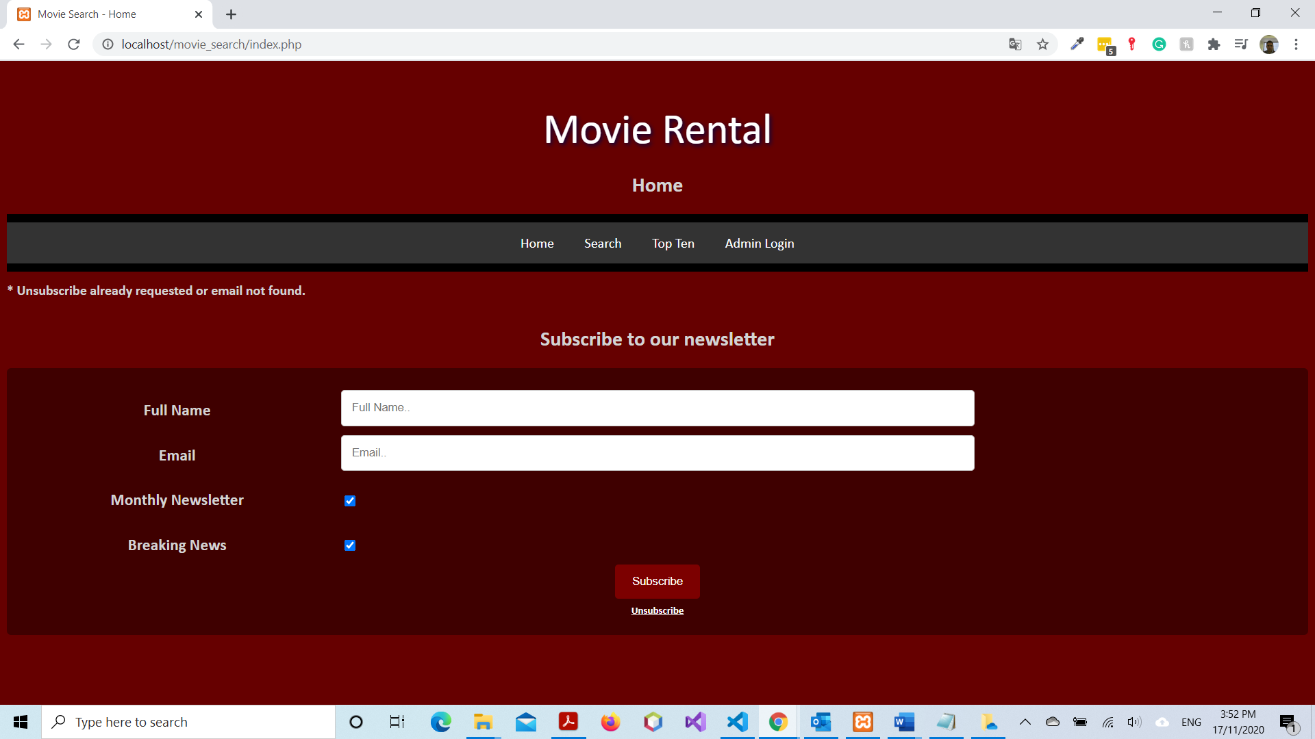

### Figure 12

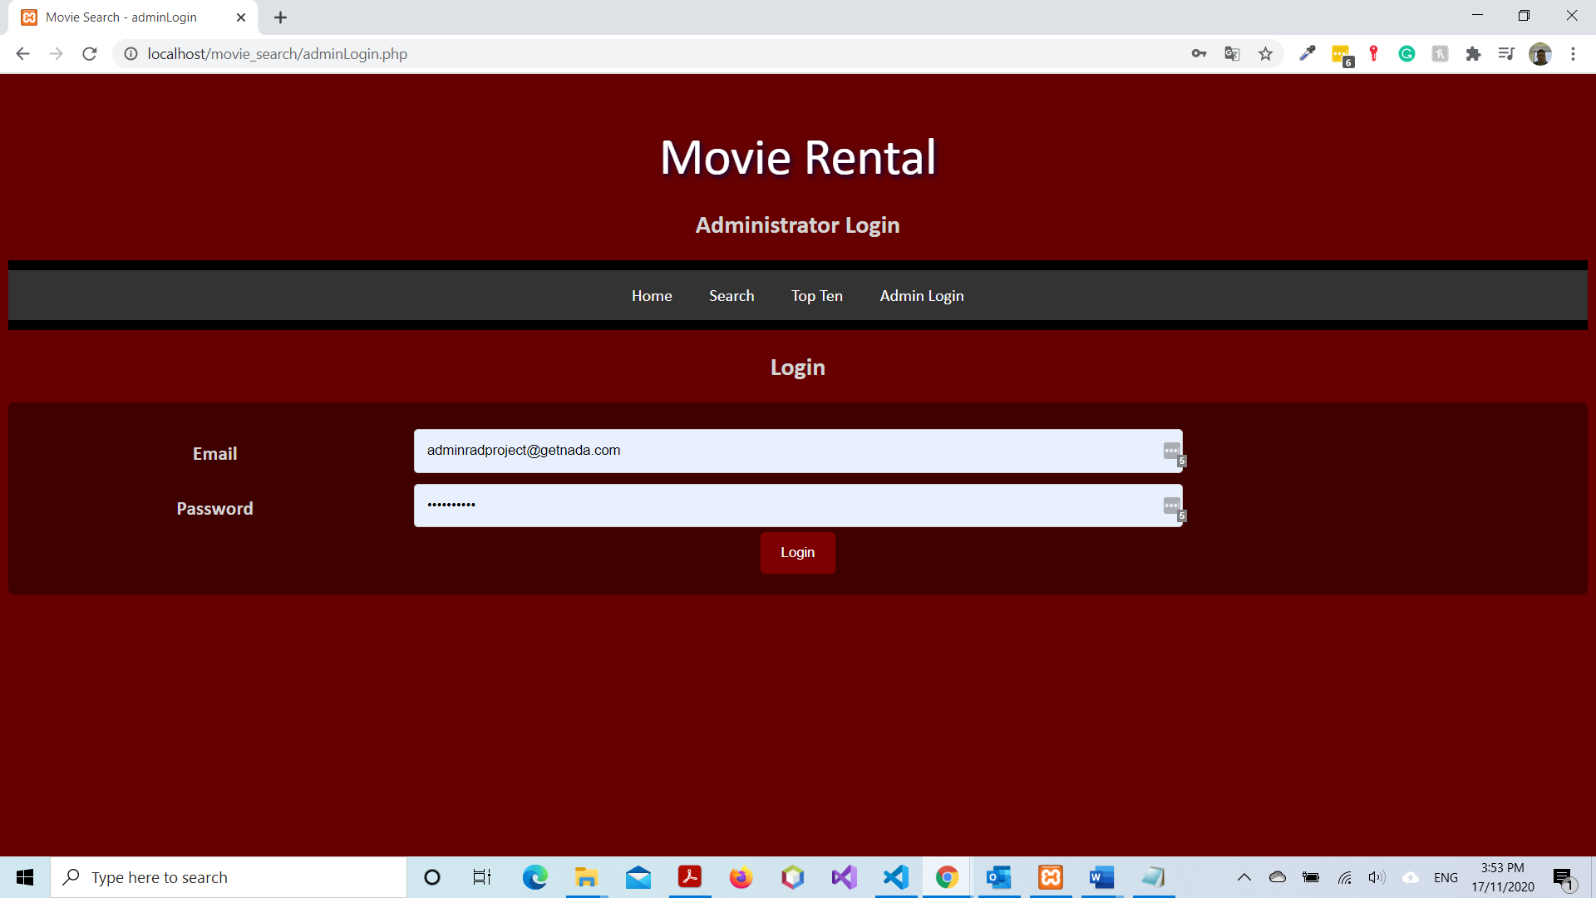

### Figure 13

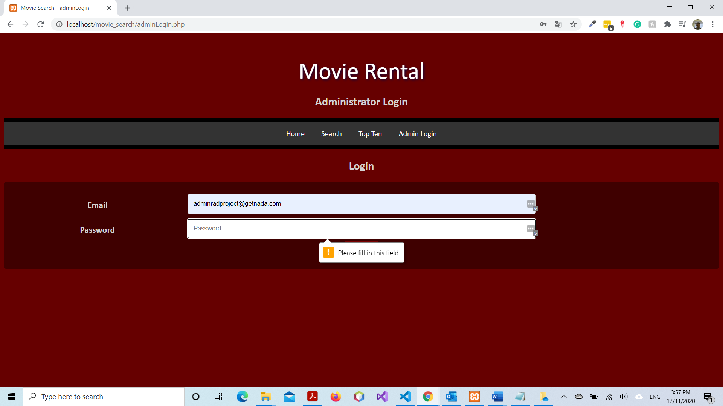

### Figure 14

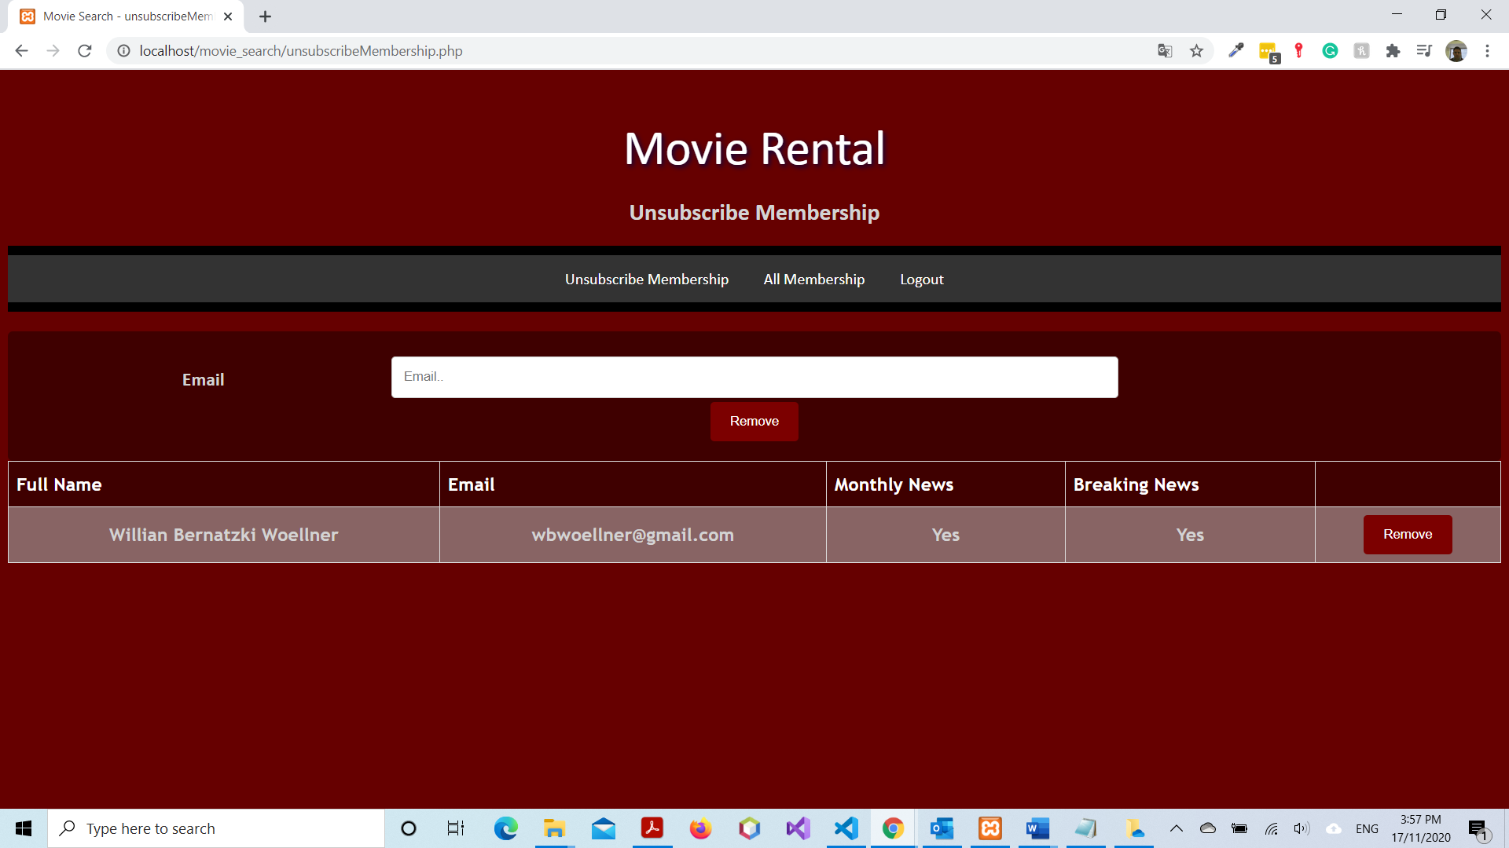

### Figure 15

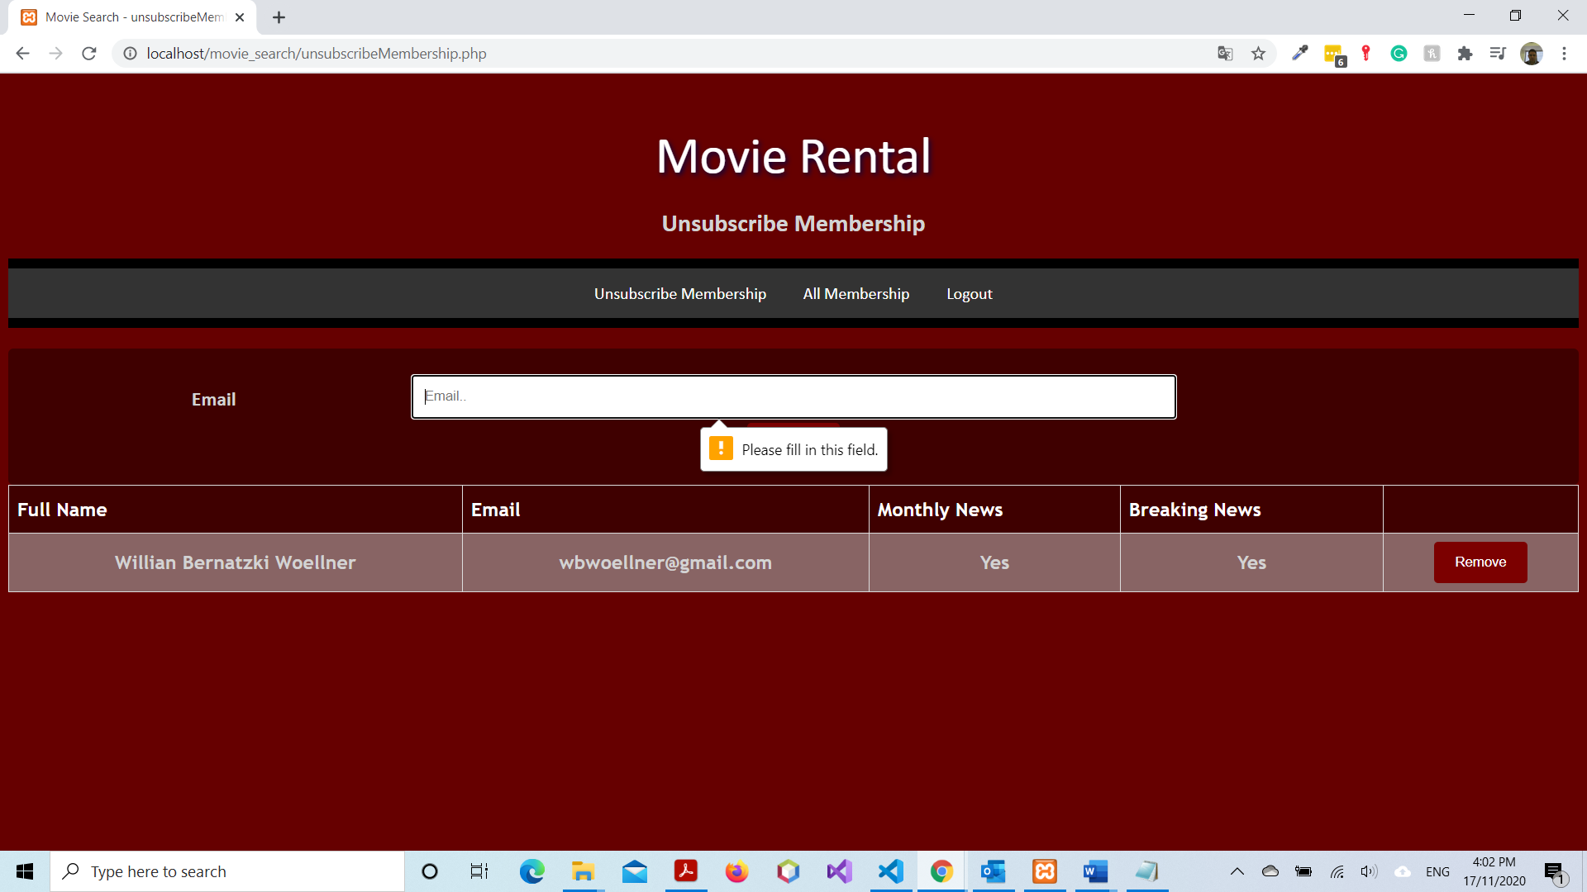

### Figure 16

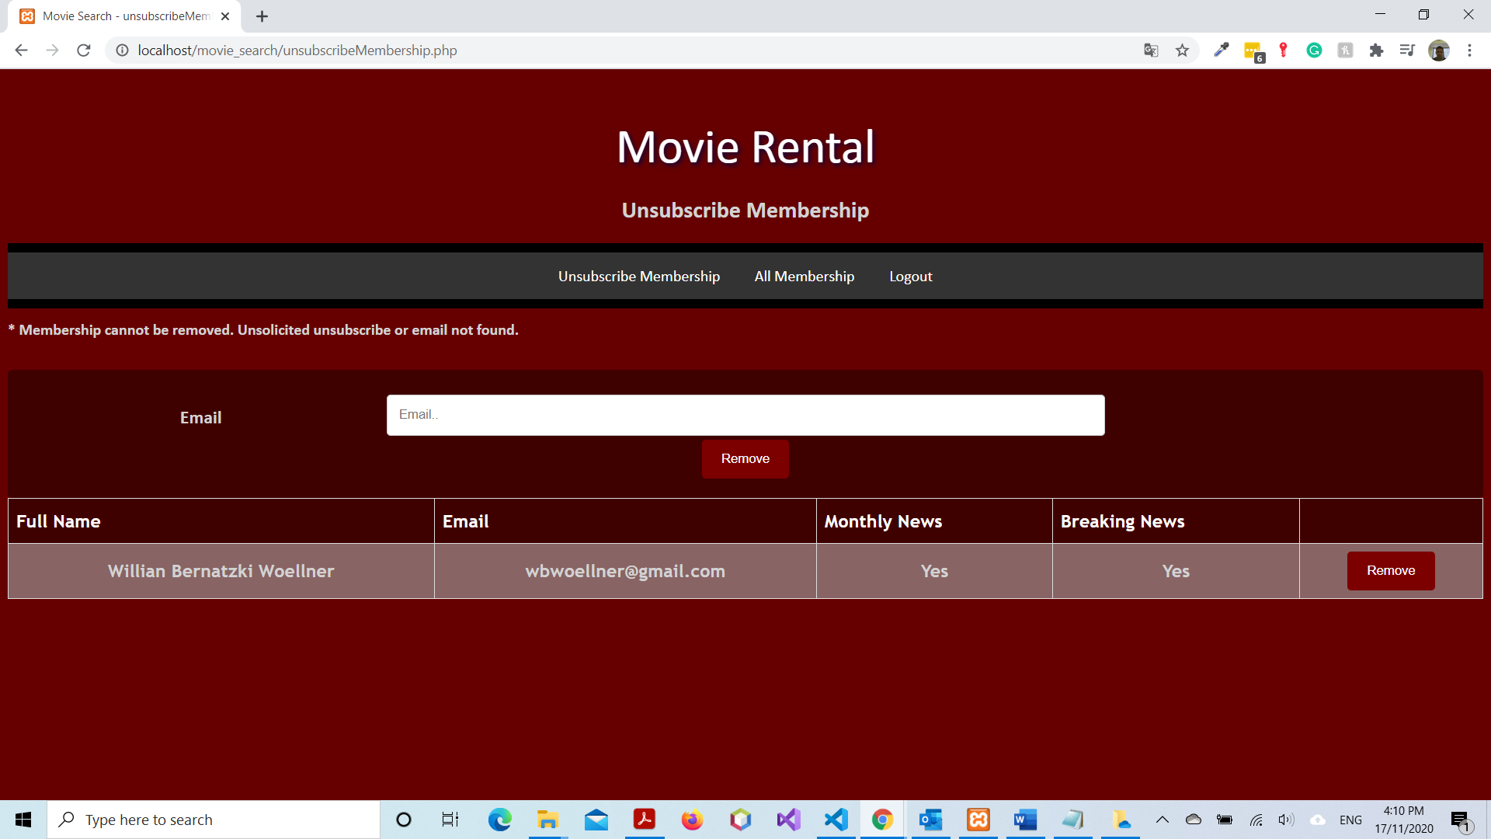

### Figure 17

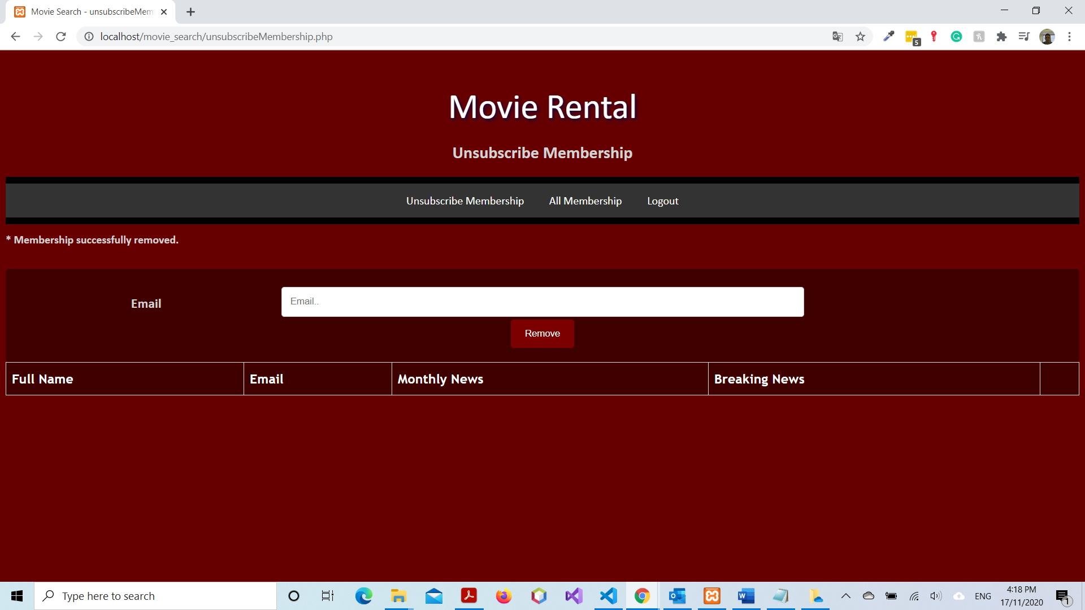

### Figure 18

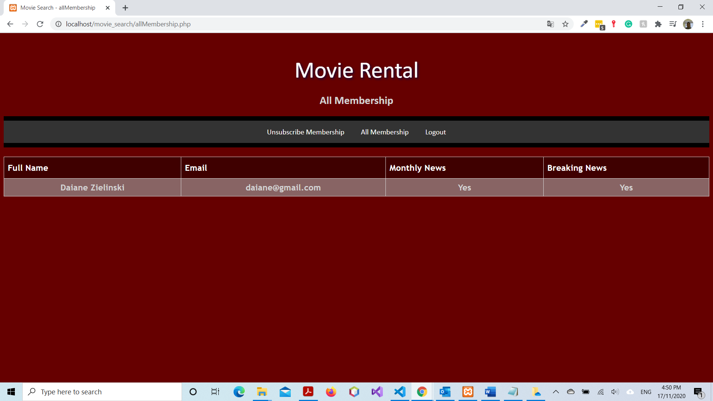

### Figure 19

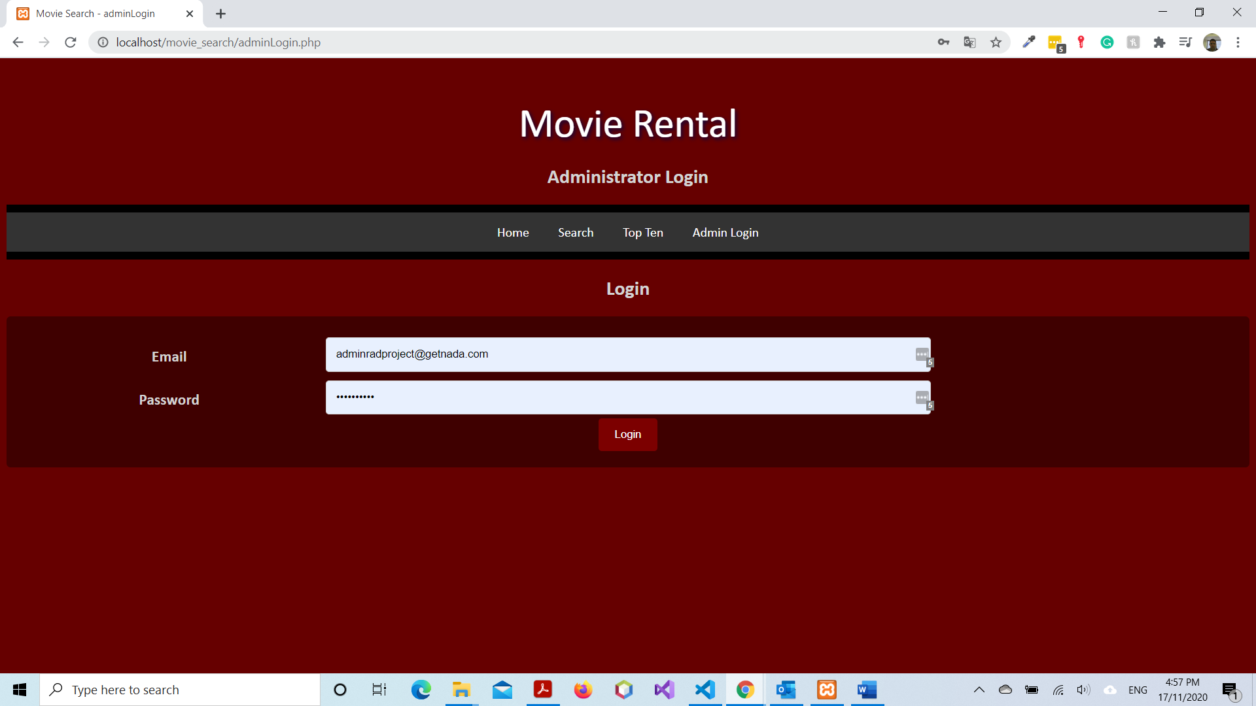

Tester: Jyle Darling

## Test Table

|  |  |  |  |  |
| --- | --- | --- | --- | --- |
| **Test Case** | **Description** | **Expected Result** | **Actual Result** | **Comments** |
| 01. | Signing up as a new member to the monthly newsletter and breaking news. | Message to be displayed showing successful sign up. Details added to the database. | As expected. | Ref figures 1 and 2. |
| 02. | Unsubscribing from membership. Email address is in the database. | Clicking unsubscribe button provides a space for an email to be entered. Entering email will provide a message showing un-subscription was successful. Email sent to admin account. | As expected. | Ref figure 3 and 4. |
| 03. | Unsubscribing from membership. Email address is not in the database. | Message displayed showing email address is not in the database. | Message displayed showing un-subscription was successful. | Ref figure 5 and 6. |
| 04. | Logging in as administrator with invalid details. | Message displayed showing details not found. Access not granted. | As expected. | Ref figures 7 and 8. |
| 05. | Logging in as administrator with valid details. | Admin only navigation bar, and current membership table to show. | As expected. | Ref figure 9 and 10. |
| 06. | Pressing unsubscribe membership nav bar, removing email address that is flagged. | Table of members wishing to unsub is shown, removing a member via button or manual email entry removes them from the database. | As expected. | Ref figure 11 and 12. |
| 07. | Unsubscribing a member without member request. | Message displayed showing action could not complete. | As expected. | Ref figure 13. |
| 08. | All membership table clicked. | Tables shown that contains all members currently stored in the database. | As expected. | Ref figure 14. |
| 09. | Admin logging out. | After selecting logout user is taken back to home page, access to admin pages has been removed. | As expected. | Ref figure 15 and 16. |
| 10. | Attempting to sign up as a new member with invalid email format. | Popup message to show showing current error in email format. | As expected. | Ref figure 17. |
| 11. | Attempting malicious code via user input fields throughout the website. | Malicious script not to be executed. | As expected. | No images to display. |

### Figure 1

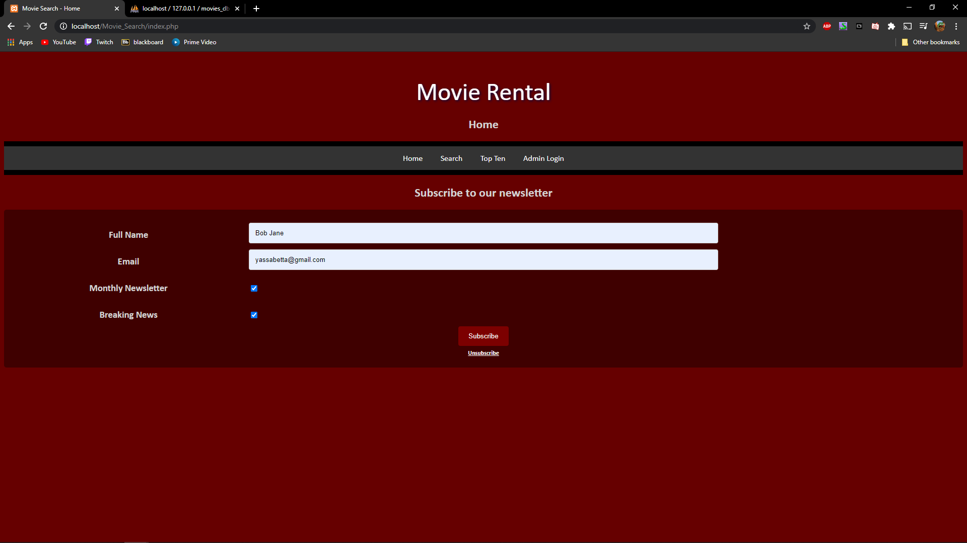

### Figure 2

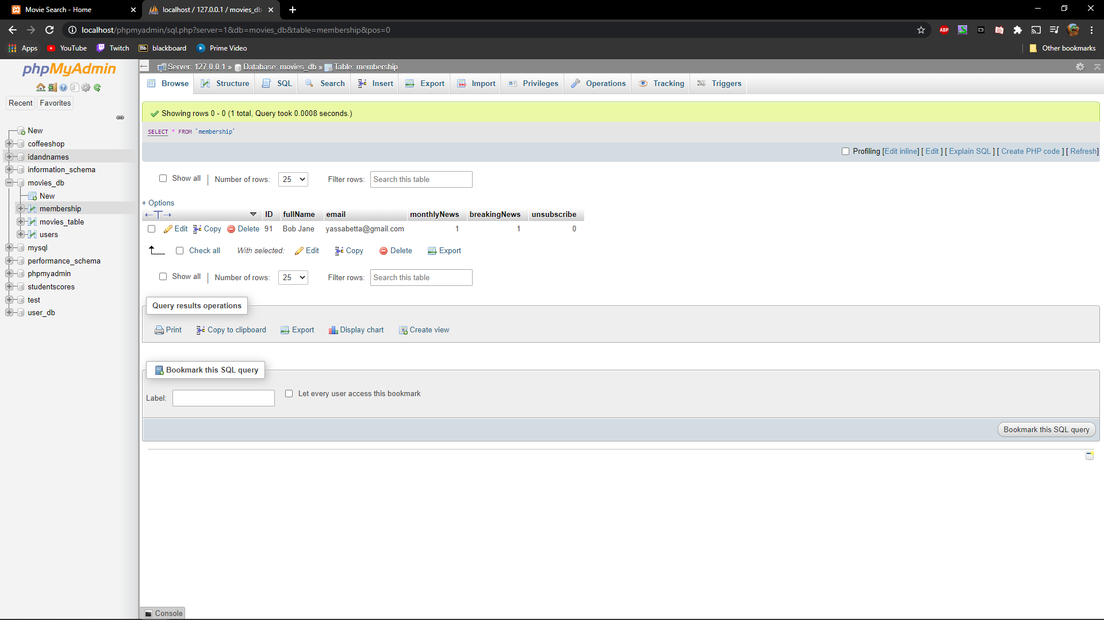

### Figure 3

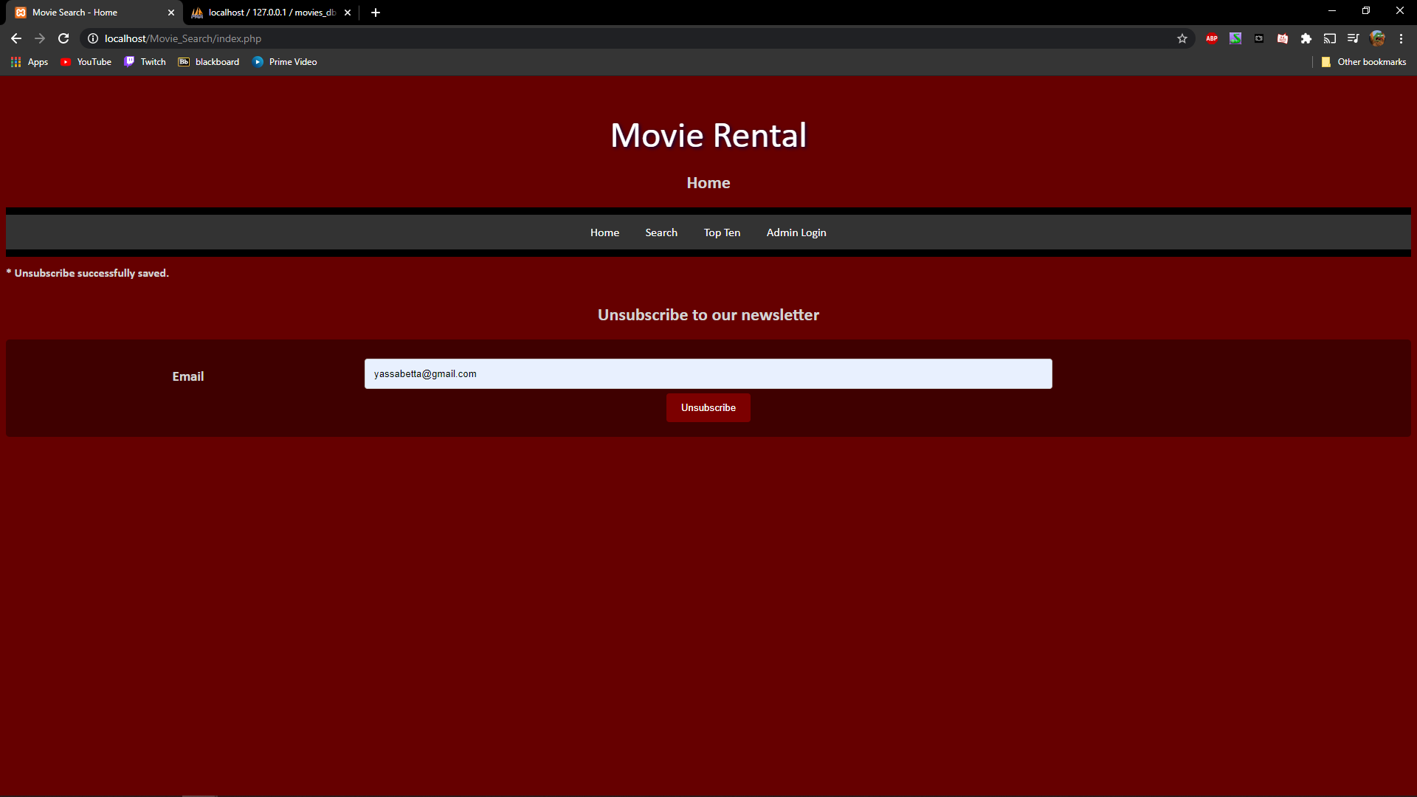

### Figure 4

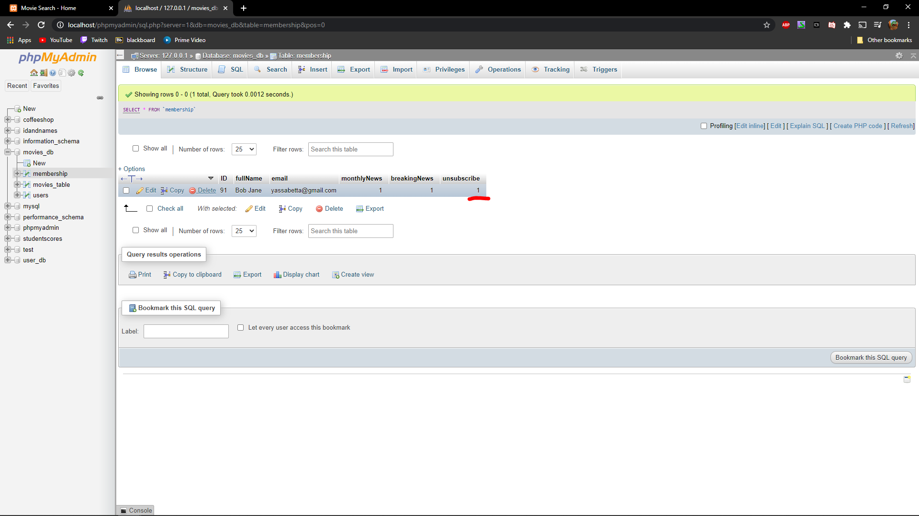

### Figure 5

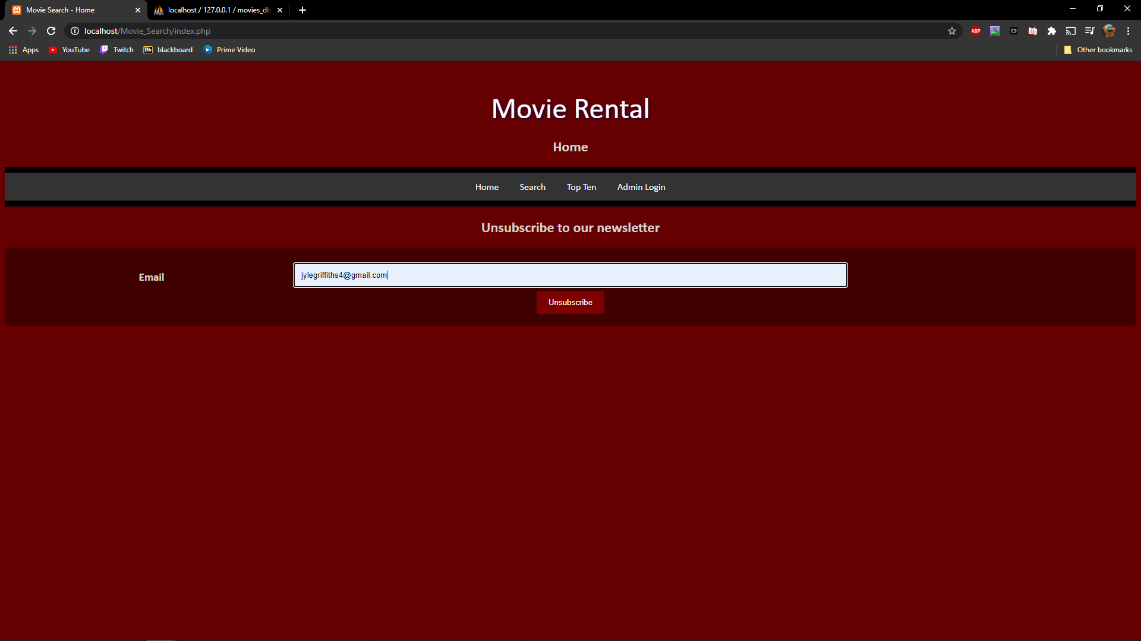

### Figure 6

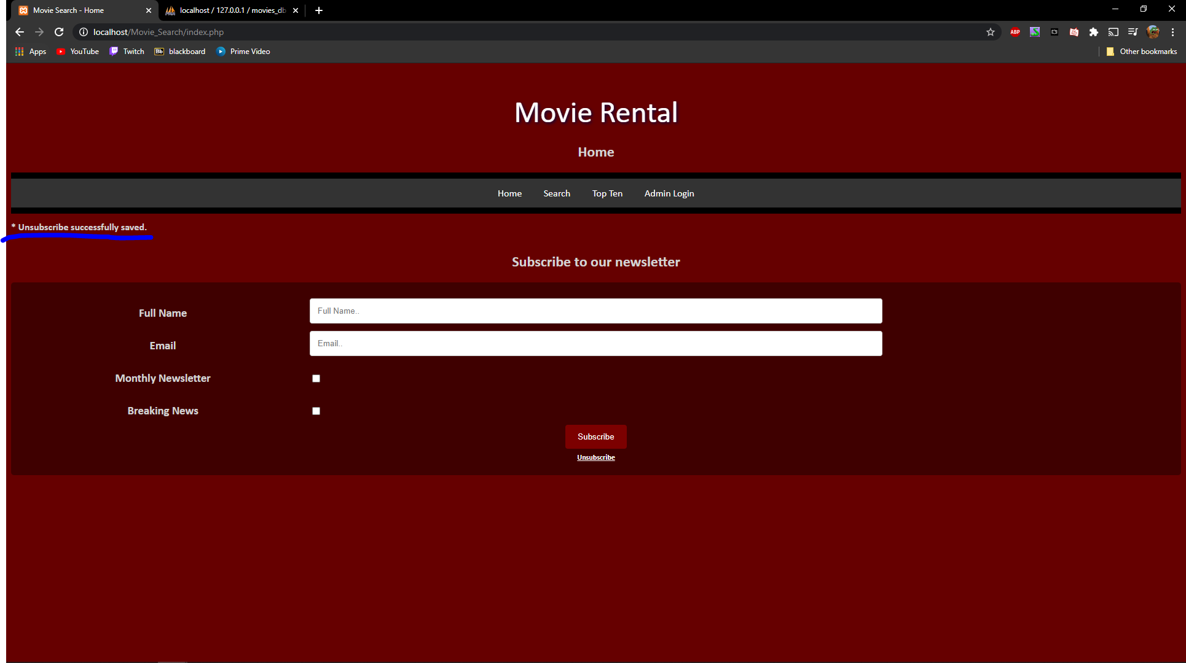

### Figure 7

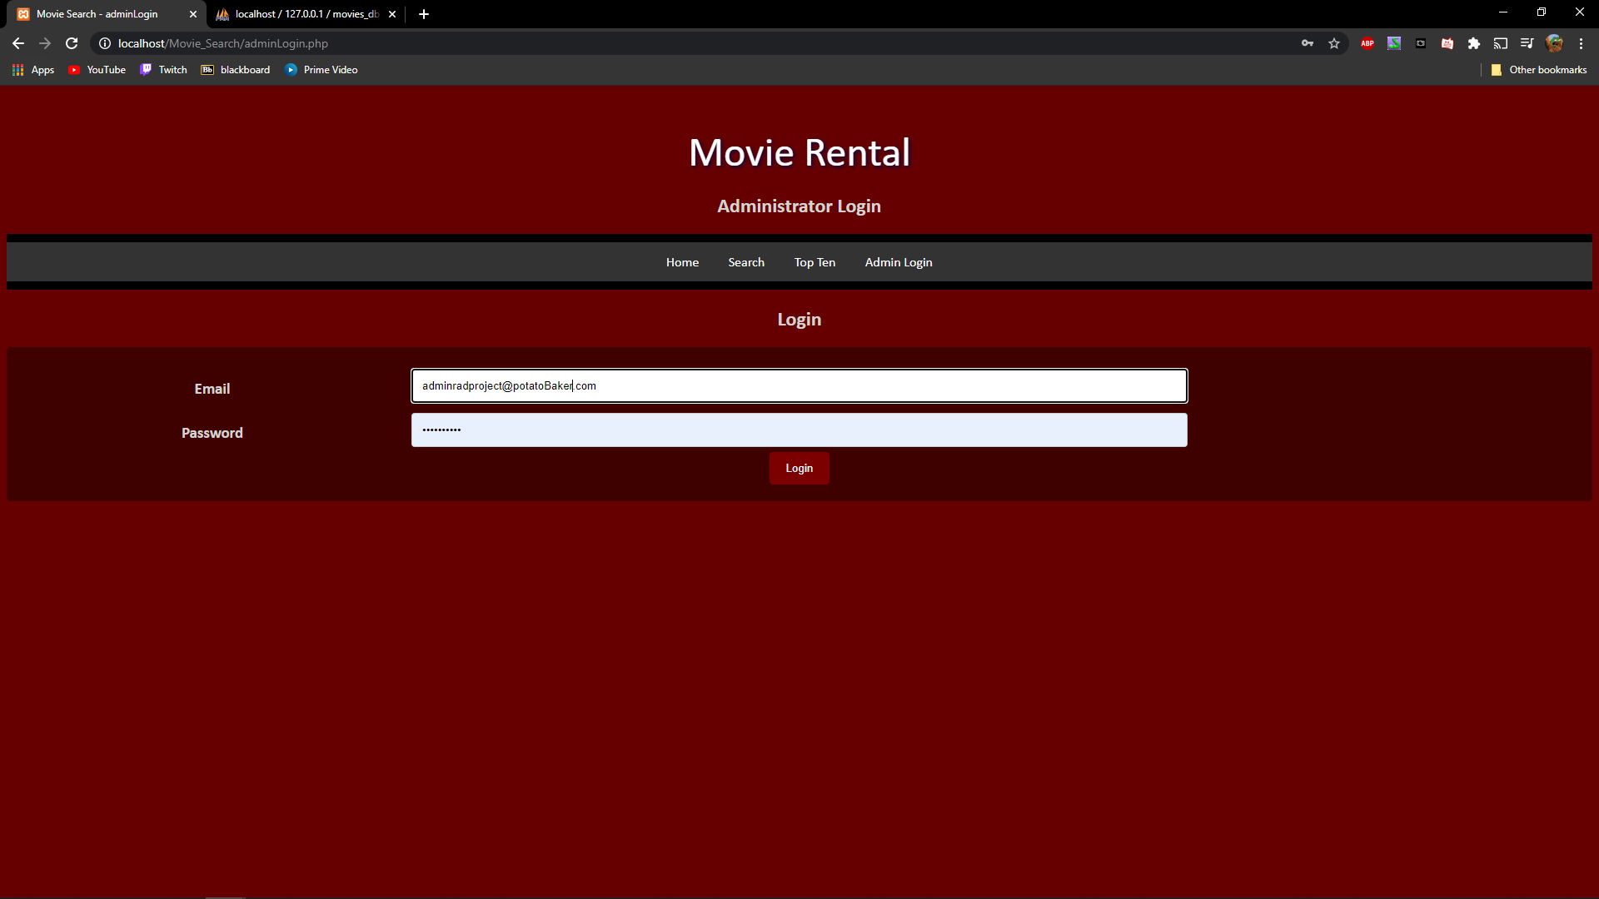

### Figure 8

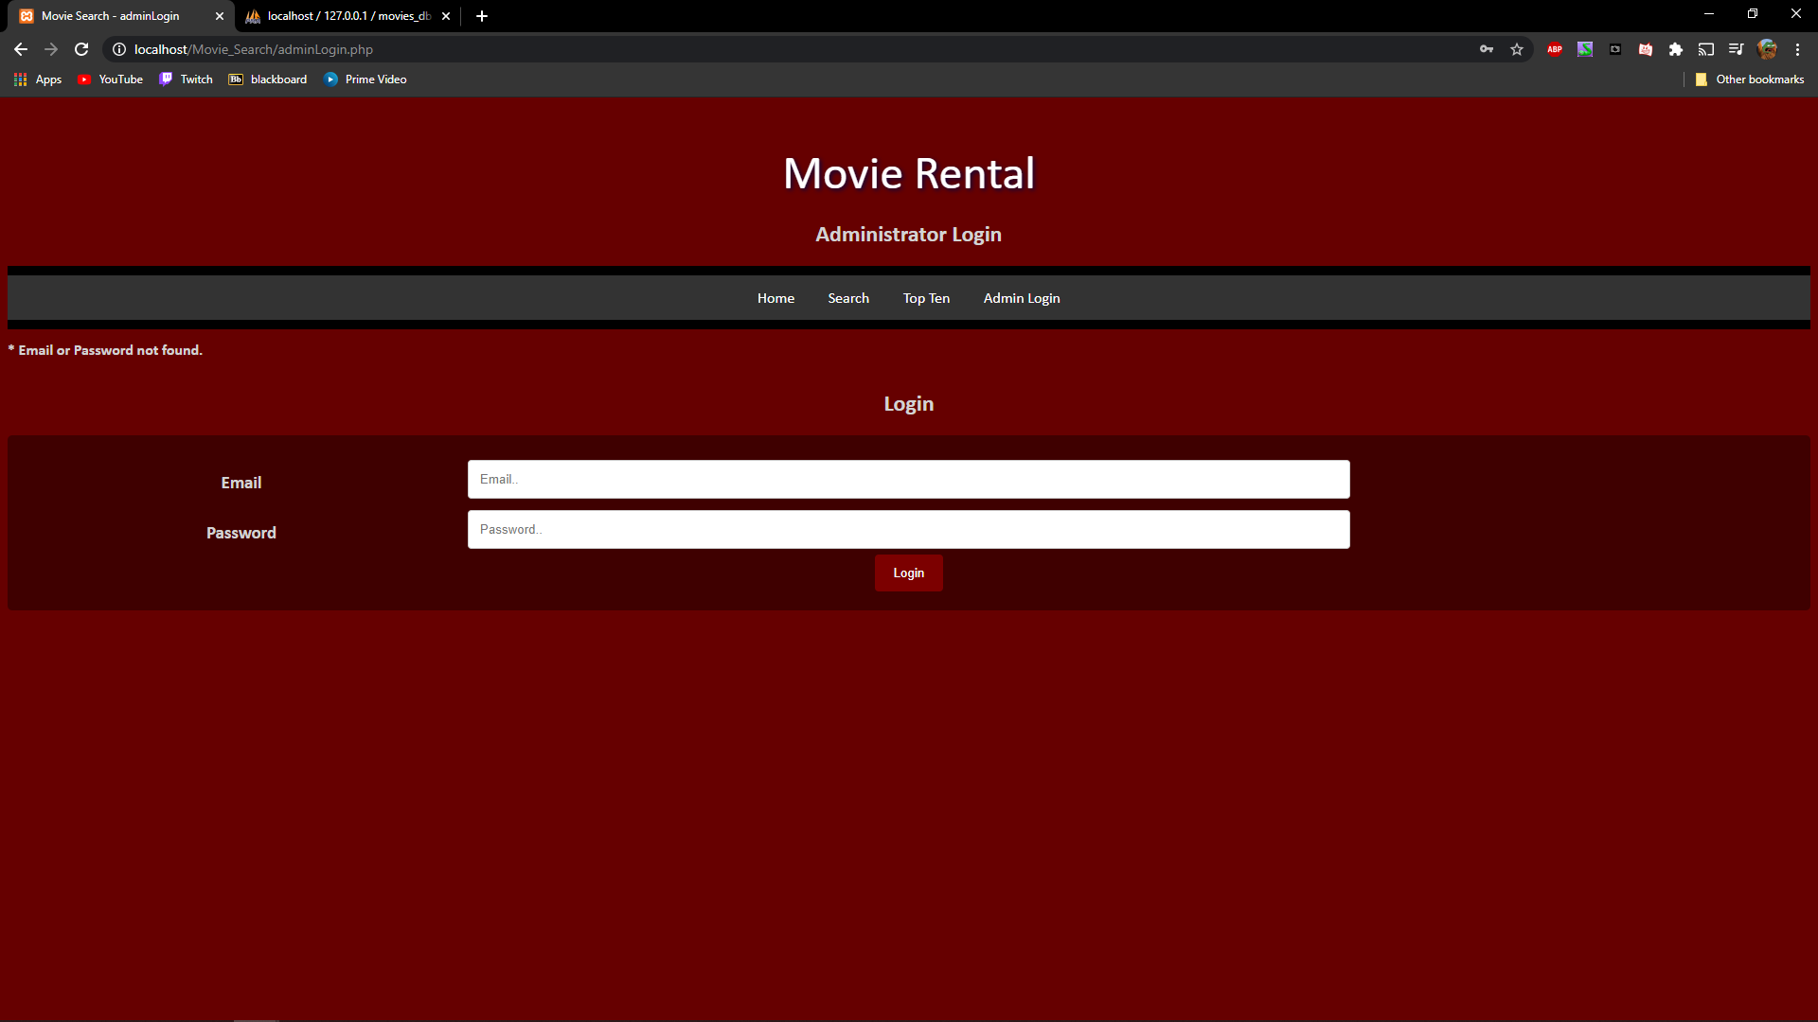

### Figure 9

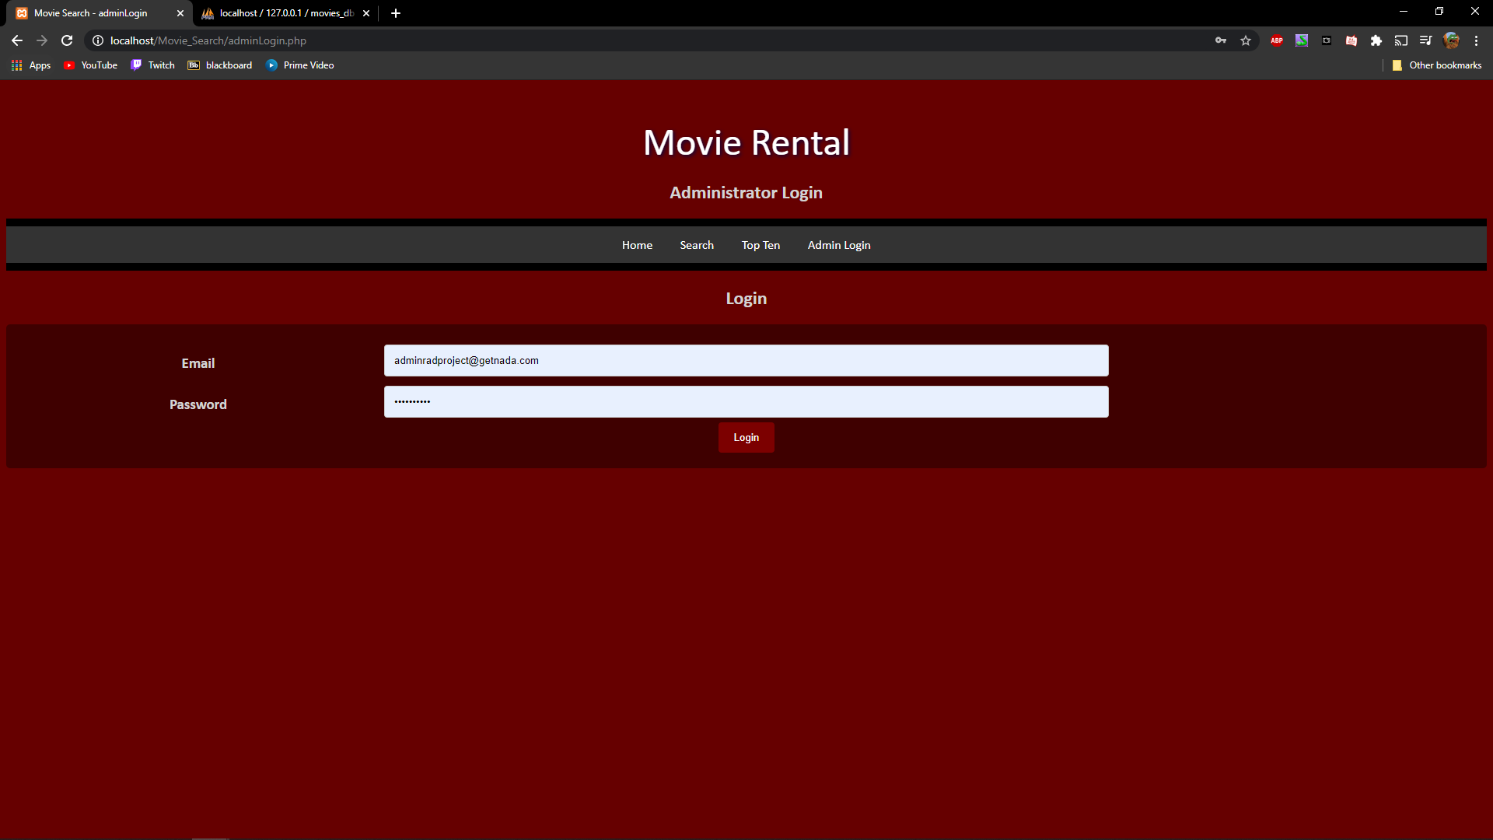

### Figure 10

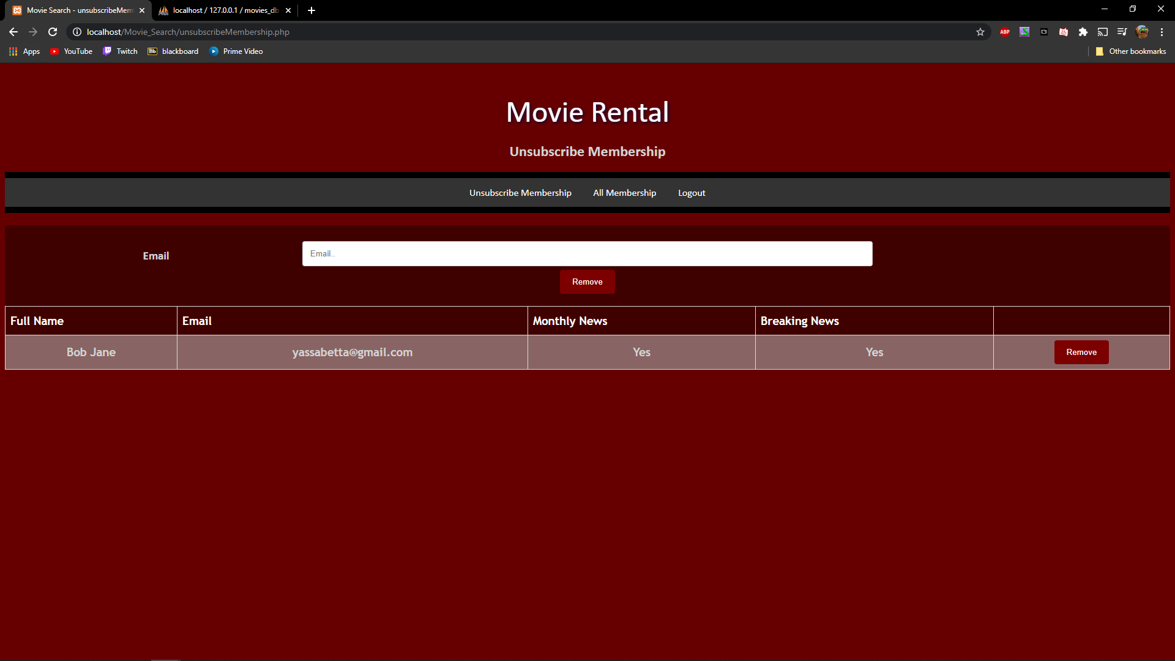

### Figure 11

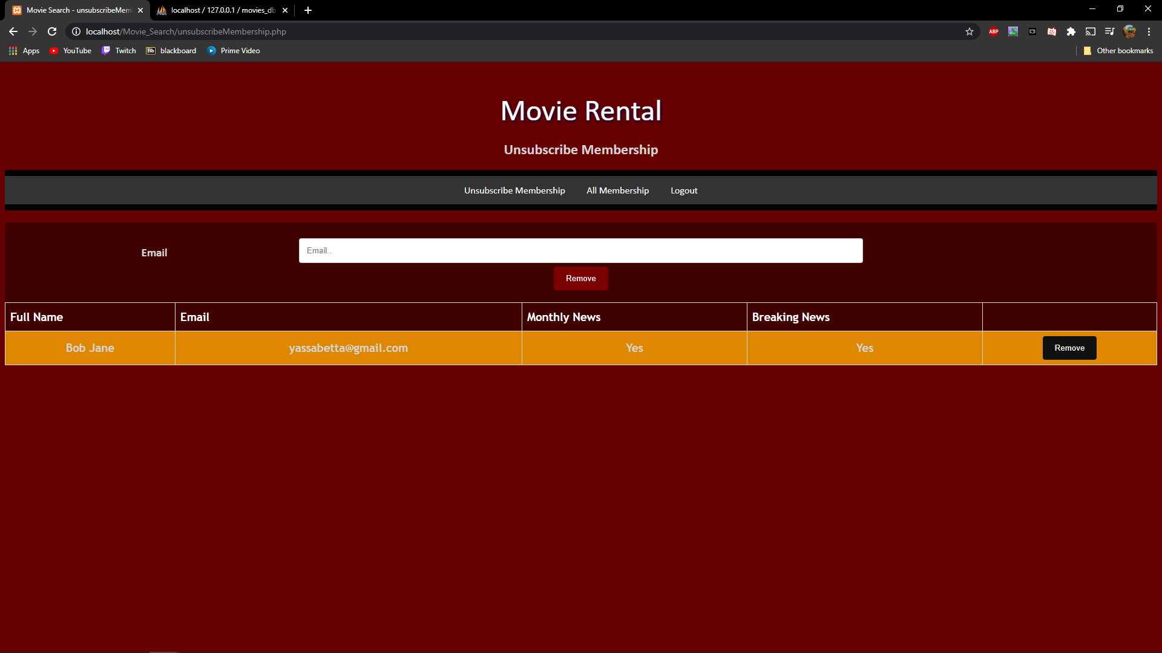

### Figure 12

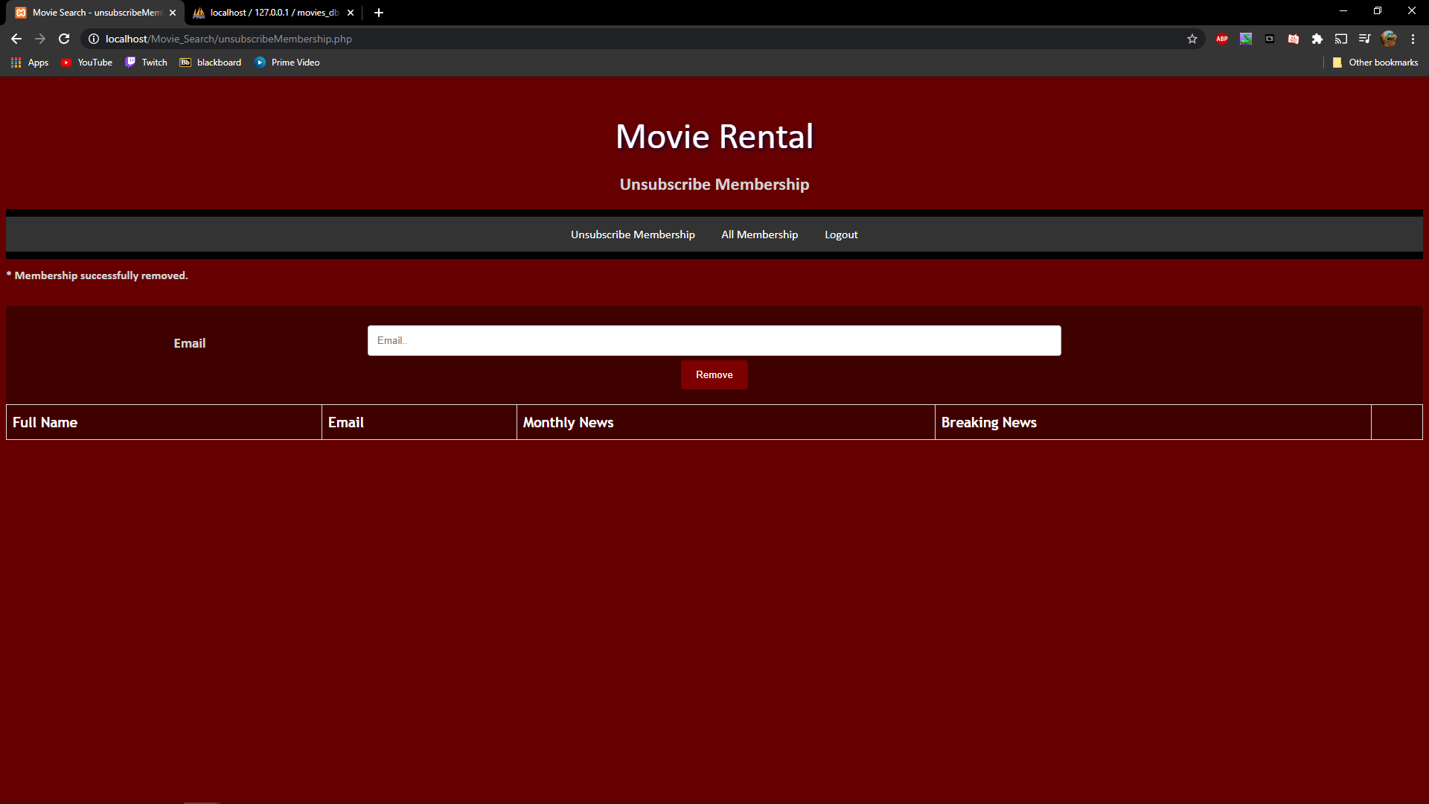

### Figure 13

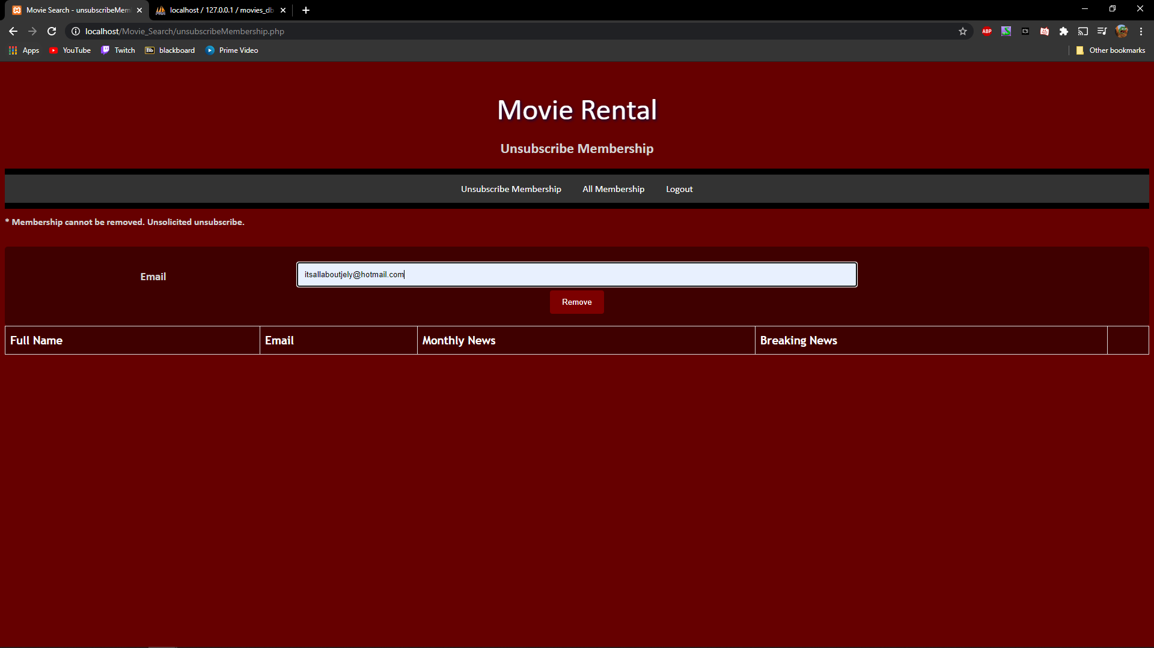

### Figure 14

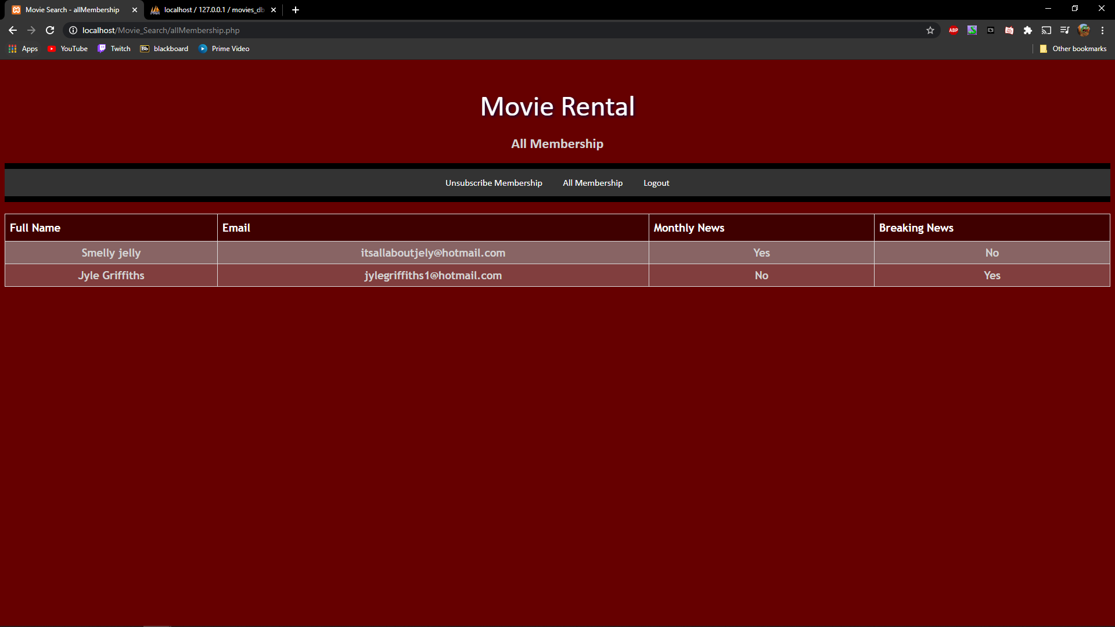

### Figure 15

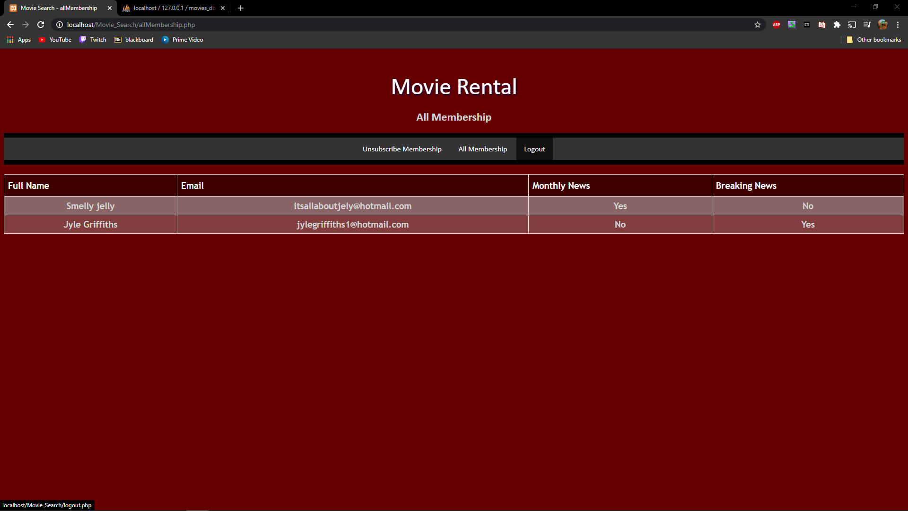

### Figure 16

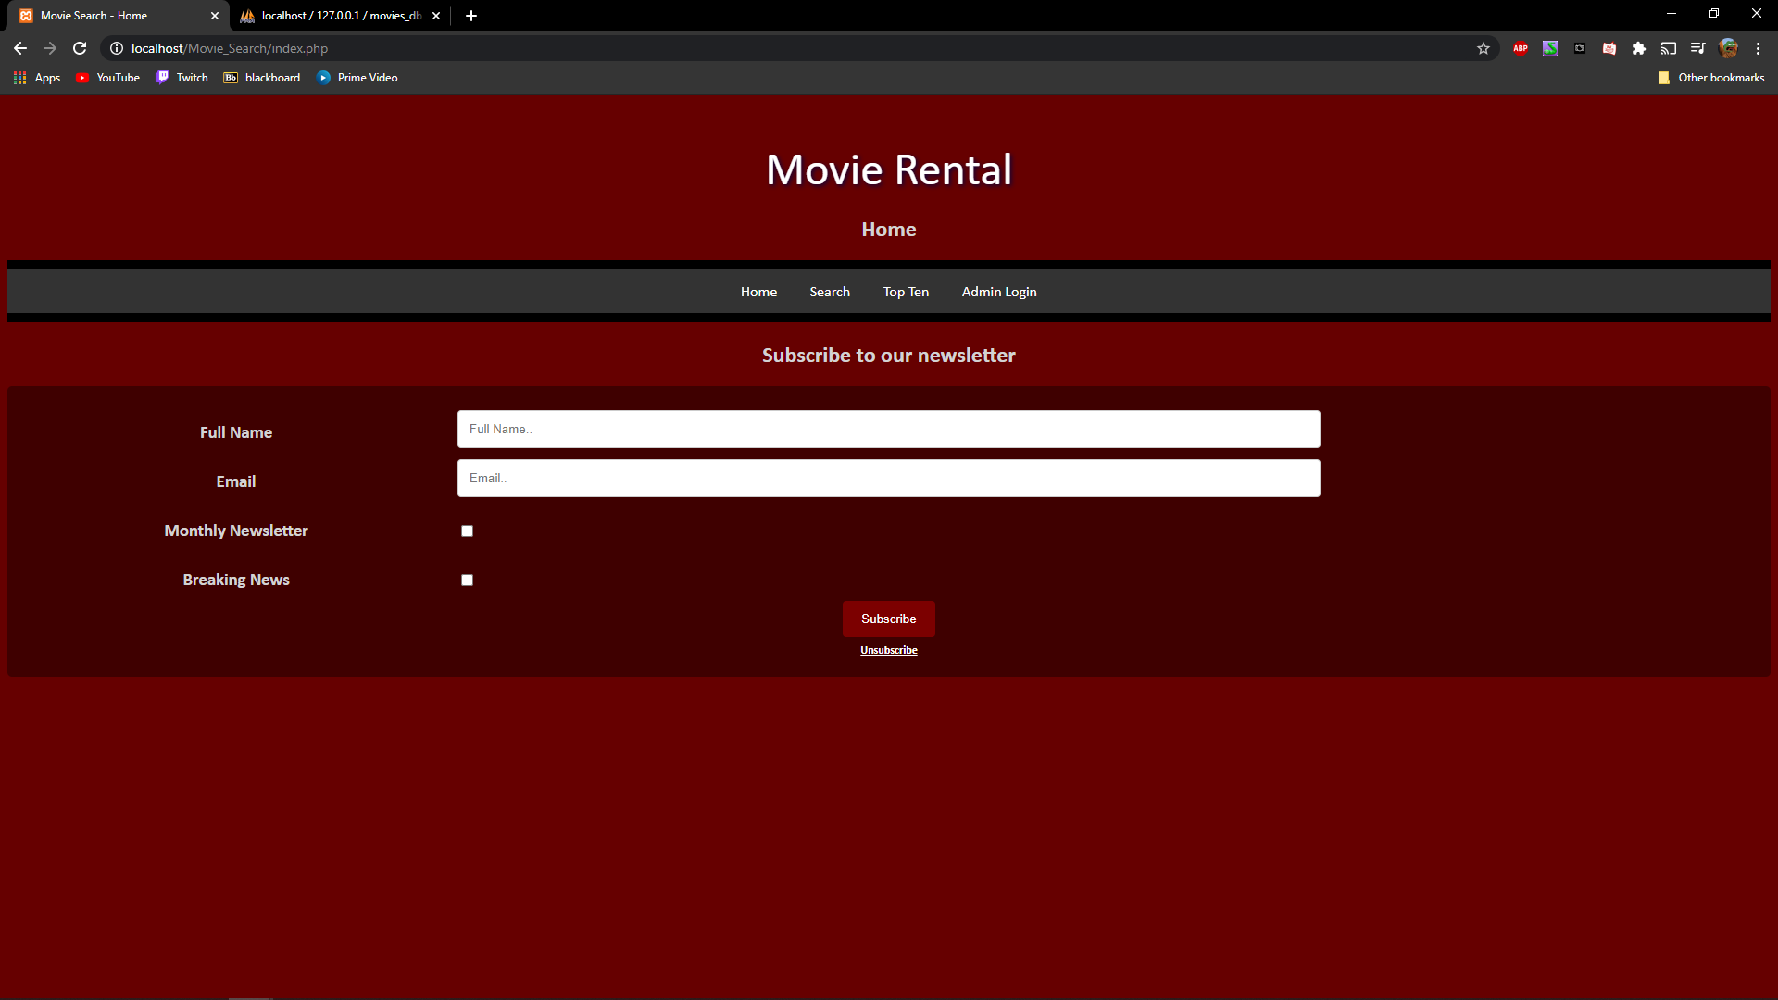

### Figure 17

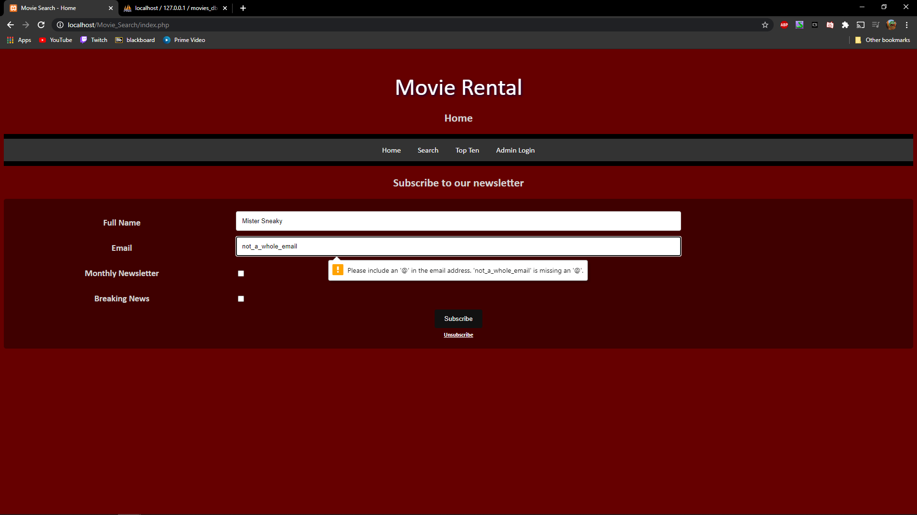

Tester: Travis

## Test Table

|  |  |  |  |  |
| --- | --- | --- | --- | --- |
| **Test Case** | **Description** | **Expected Result** | **Actual Result** | **Comments** |
| 01. Subscribe to the monthly newsletter and breaking news. | Enter my info and click subscribe. | Website informs me I am subscribed and info added to database. | Correct | Ref. Figure 1 Ref. Figure 2 |
| 02. Unsubscribe for newsletter and breaking news. | Click the unsubscribe link then enter email and click unsubscribe. | Website informs me I am unsubscribed and info removed from database. | Correct | Ref. Figure 3  Ref. Figure 4 |
| 03. Log in as administrator. | Enter email and password for administrator access and lick login. | Website informs me I’m logged in as administrator. | Correct | Ref. Figure 5 |

### Figure 1

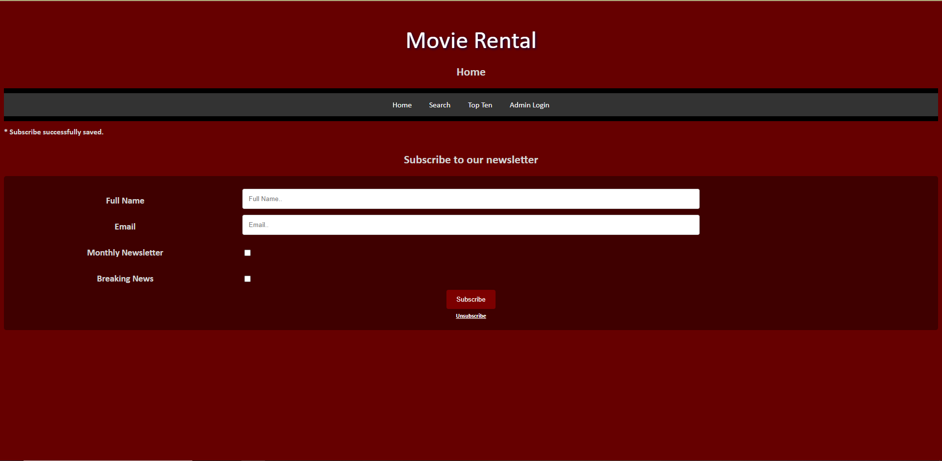

### Figure 2

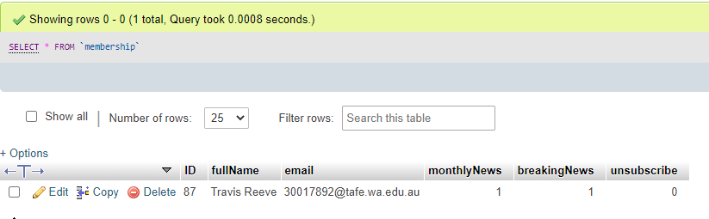

### Figure 3

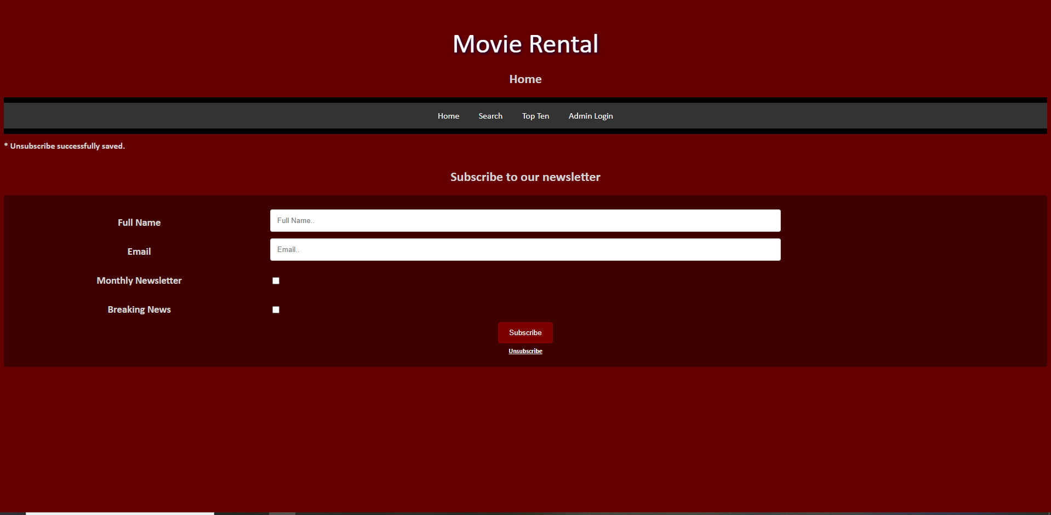

### Figure 4

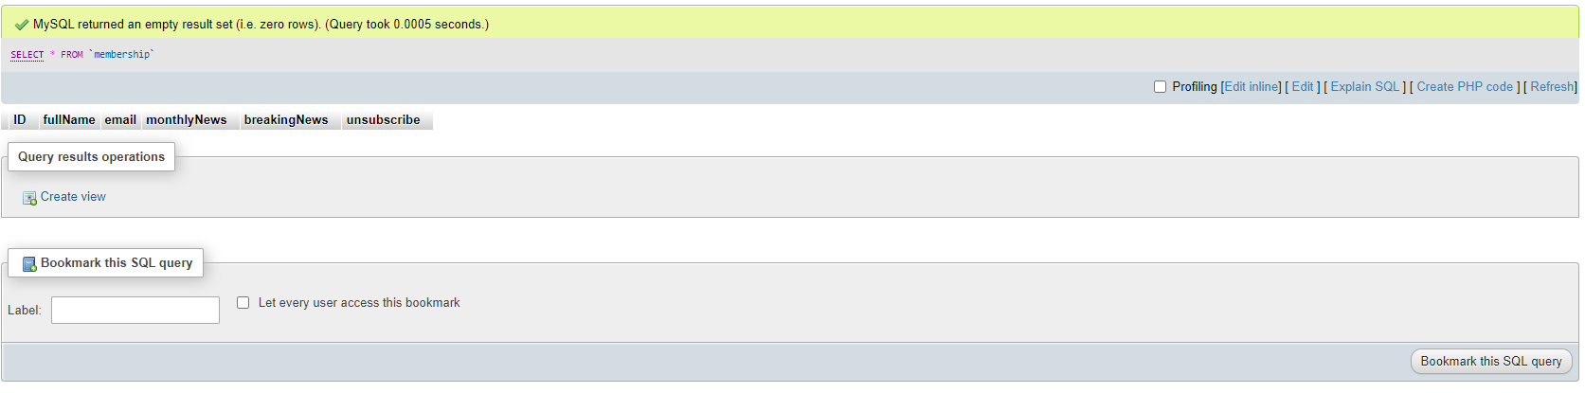

### Figure 5

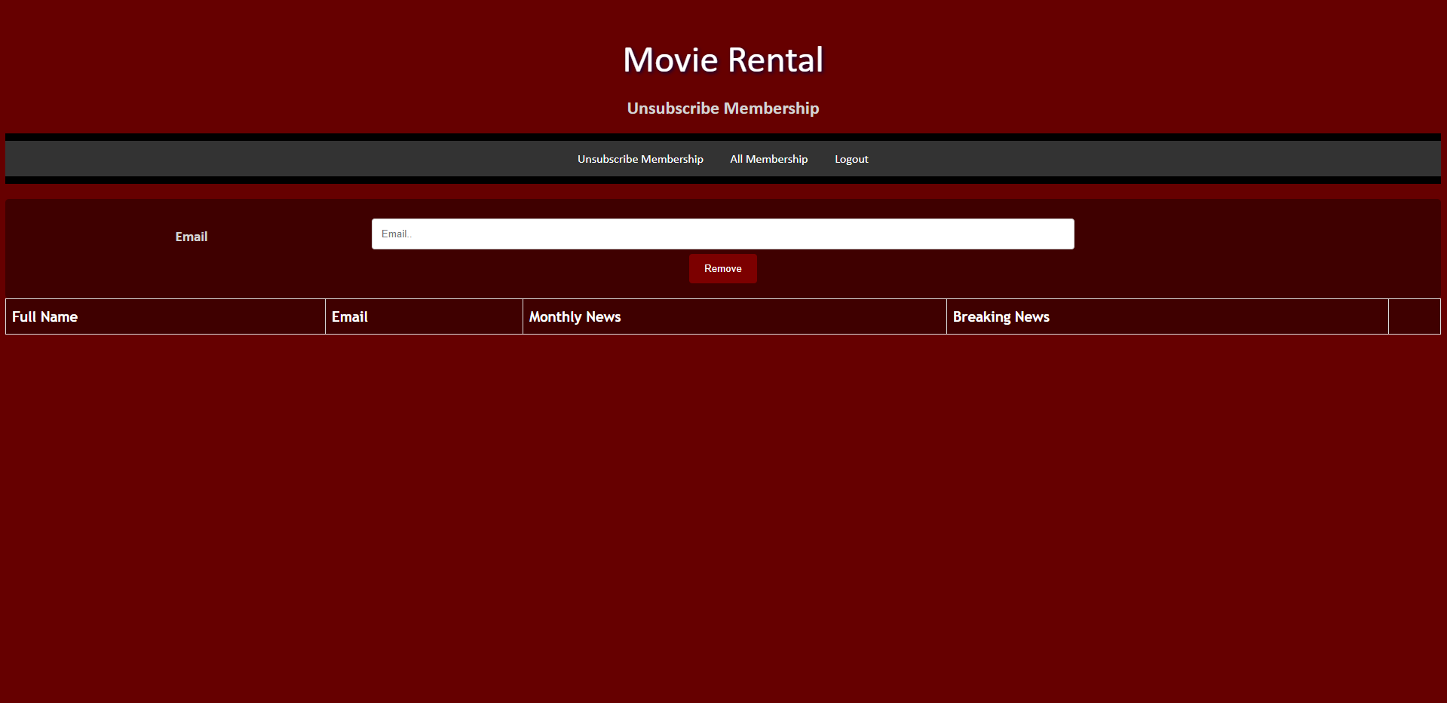

Sprint Three

Scrum Master